## Session 1.5

How To Train Your Model with Project Refinery

Matt Jezyk, Tesla and formerly Autodesk



**Class Description**

Project Refinery is an Autodesk generative design tool for the architecture, engineering and construction industry that gives users the ability to explore, analyze, and optimize their Dynamo and Revit designs.

Creating parametric options is easier than ever, but creating 'good' options is still quite hard. Creating good design options starts by asking the right questions, and then by embedding your custom design logic into code. This lab will feature pragmatic end-to-end workflows for architectural design option generation and evaluation using Project Refinery in Dynamo for Revit. We will teach you how to code 'Evaluators' and train your model using Project Refinery.

We will focus on these workflows and focus on the Evaluators for each:

1. Massing Study Simple – a simple workflow to explain concepts.
2. 2d Hill Climbing – showing how to create define a goal or objective function and create Evaluators using either Dynamo nodes, DesignScript, Python or C# code
3. Massing Study Complex - retail and office distribution and configuration for a building on an urban site. We will also show how to take an evaluator from a different project (StealthyRoofscapes) and apply it to this one.
4. Solar Analysis – Using Simulation Results
5. Office furniture layout – desk layouts in a Revit room that provide the most desks but also the most private desks while maximizing desk area per person and minimizing unutilized space.

At the end of this session, participants will be able to:

1. Frame a design problem in terms of goals and constraints
2. Learn how to write psuedocode to help define the logic before writing final code
3. Develop new custom code in multiple programming languages (Dynamo, DesignScript, Python, and C#)
4. Test the custom logic in a larger generative workflow

**About the Speaker:**

Matt Jezyk works as the Sr. Staff Software Engineer at Tesla in the group that designs and builds the ‘Gigafactories’. He develops software to smooth out the design, fabrication and construction process. Matt’s group is responsible for developing smart factories for upcoming Tesla products.

Prior to his current role, Matt was the Senior Engineering Manager for AEC Generative Design at Autodesk. He has been in the AEC industry for 23+ years and has spent the past 20 years developing Autodesk Revit and various other design tools. Matt helped build Revit Architecture and Revit Structure and led the team at Autodesk responsible for developing Dynamo (computational design) and Project Refinery (optimization and generative design). Dynamo is now being used around the world and has an amazing community of users who now teach these techniques at many events and conferences.

Matt’s group also has explored new ways of building by connecting computational and generative design directly to digital fabrication tools and robots. Examples of this have been shown in the BUILD space in Boston and presented at conferences like ACADIA, SmartGeometry and Robots in Architecture

## Introduction

This class is about how to use generative design workflows to advance architectural processes.

### Why learn about generative design workflows?

By 2050 there will be 10 billion people on earth. The global middle class is growing faster than at any time in our history. In 1990, only 23% of the global population had sufficient income to be classified as middle class. Today, 45% of us do. All of these people are going to drastically increase the population of our cities and this is going to require a lot of work: a lot of new buildings and infrastructure to support them. Recently Autodesk partnered with a firm called Statista to calculate just how much work.   We’re going to have to build 13,000 buildings every day and enough roads and rail to wrap around the earth six times every year. That’s over 1.2 million km of roads and rail needed for our global infrastructure each and every year between now and 2050. I’m going to assert that there is a problem: we need to produce more work at a higher quality with less resources. In today’s design processes, most people just evaluate a few designs and make decisions based on rules or thumb or instinct, generative design can let you study much more data driven designs to achieve better outcomes.

The traditional way of delivering buildings has been recording designs on paper and delivering the drawings to others who execute to build it. We've evolved to computerizing drawings making them more data rich and easier to update. But what we really want to do now is to combine intelligence of building professional with algorithmic intelligence of a computer to produce better buildings, faster. Autodesk Research has been experimenting with some ways to do this. The following studies are some examples of their work.

### Research Example 1: Autodesk MaRs Office Design in Toronto

A few years ago, Autodesk moved our Toronto office to a new office in the MaRS innovation district. The Living, an architecture firm that Autodesk has incorporated into Autodesk Research to test out ideas, used a generative approach to design the new office’s space layout. They began by surveying existing employees and asking them questions like “Who do you need to sit by?” “How much daylighting do you need to do your job?” “How much distraction can you handle?” When they had all of this data they identified 6 goals that they felt would make a “good” office.

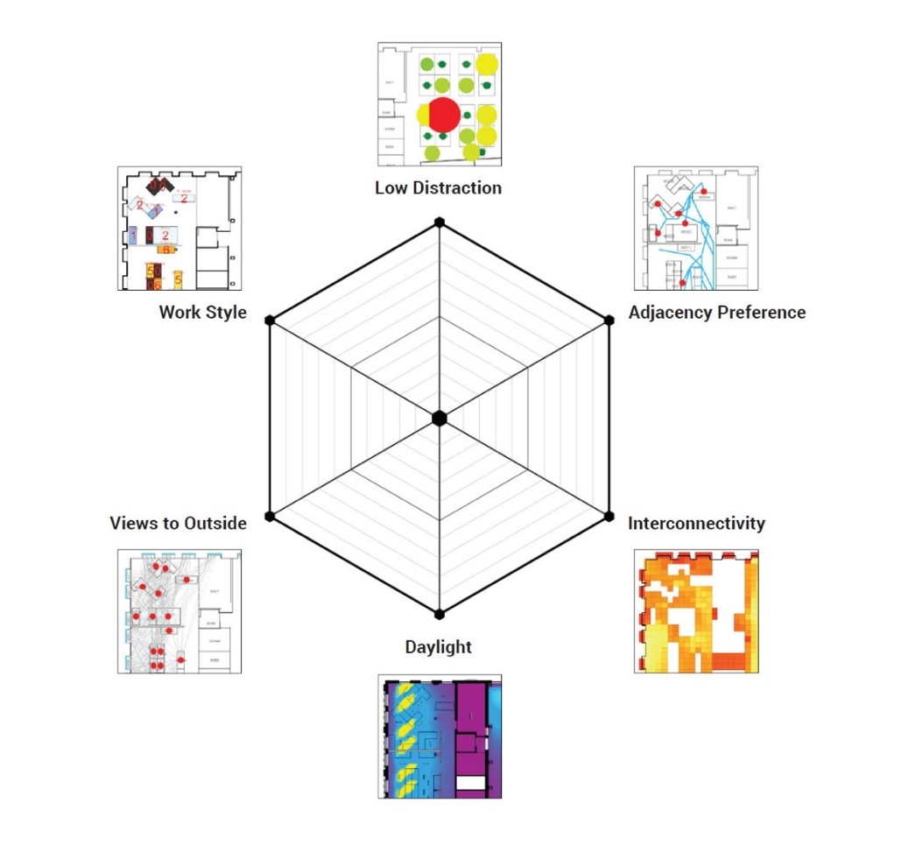

Autodesk MaRs office design goals

Algorithms were developed to measure these goals and tested the measurements on their existing office space. Here is an example of a way to measure low visual distraction. Note that the scoring equation is critical to the evaluation of the goals.

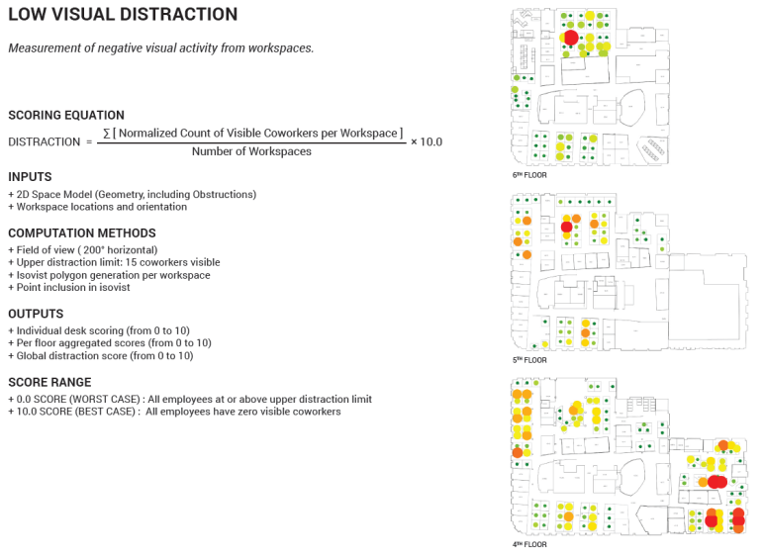

A flexible model was built to generate designs that could be tested against the goals.

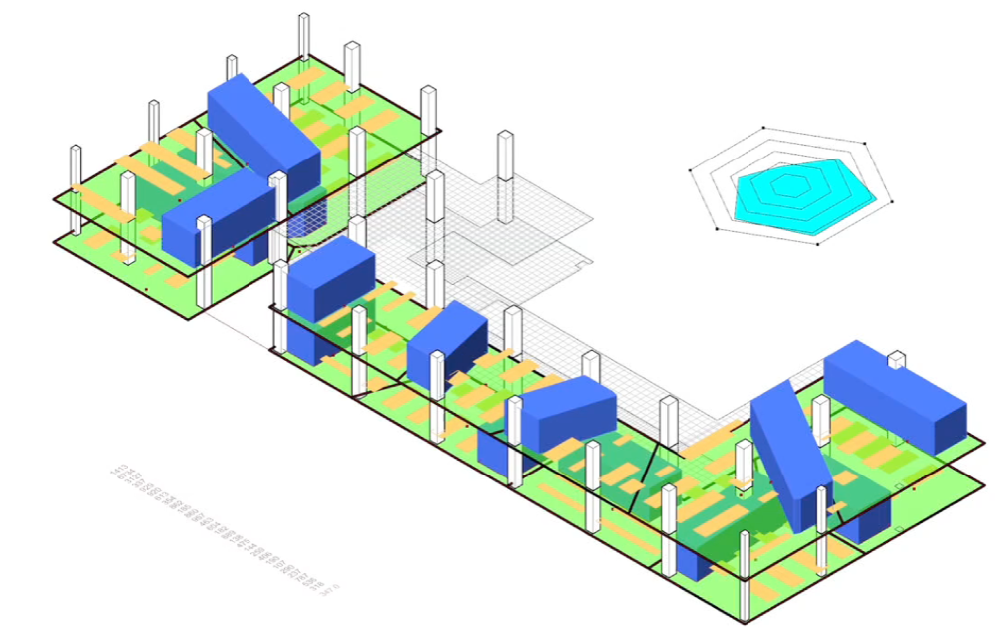 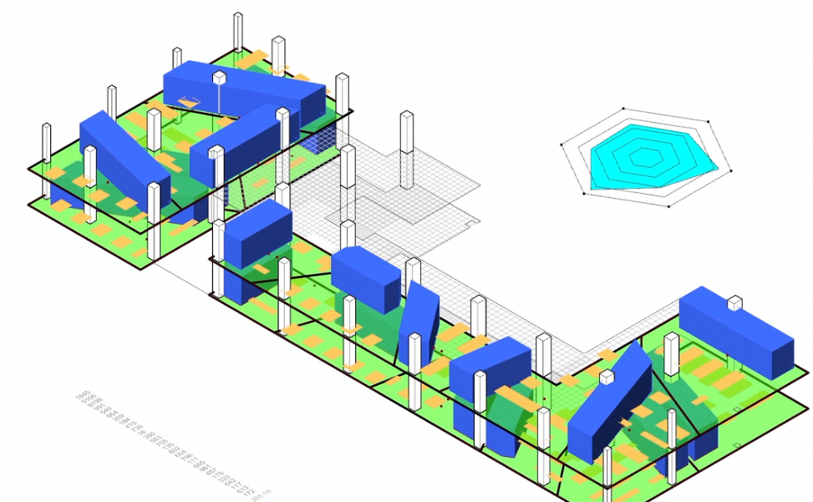 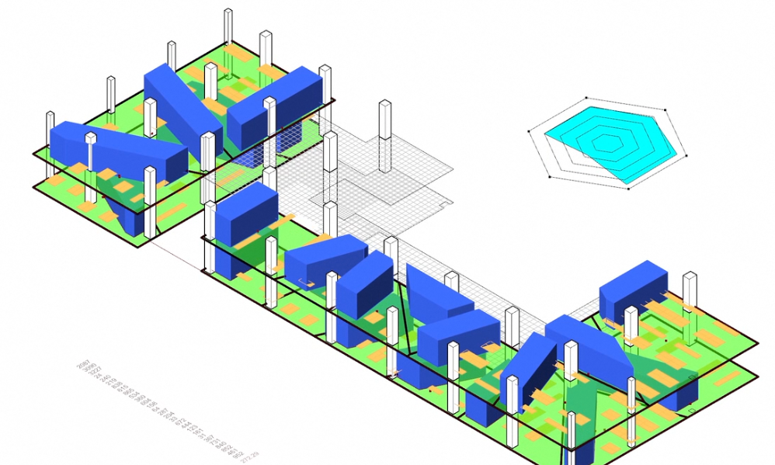 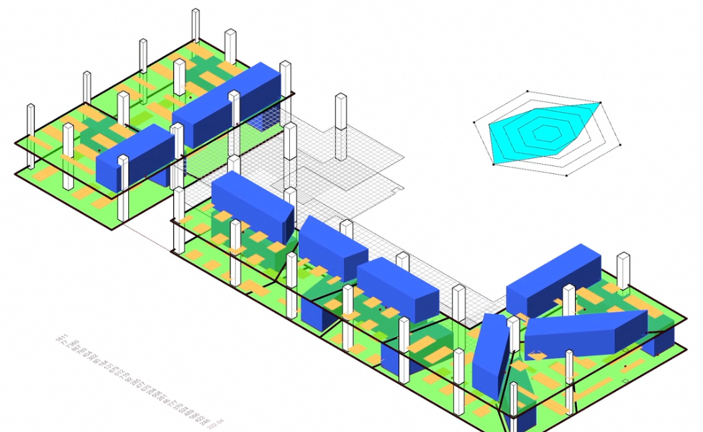

Autodesk Mars Office Design Project

Different floor plan layouts were generated from the model including blue amenity bars of meeting rooms and yellow locations of desks. Each design option also feeds data into a dashboard showing performance across the six goals. Variables were set up so that designers could flex the model and see what the effects of the variables are. 10s of 1000s of options were created and a methodology was developed to sort and help make decisions. Optimization algorithms were used to help evolve the designs towards identified goals. By clearly defining goals before the options were generated, the computer was able to assist the design team in producing not just more designs, but designs that better met the stated goals.

### Research Example 2: Van Wijnen Neighborhood Design

Autodesk Research and The Living also worked on a project with the Dutch construction company Van Wijnen. In this project they followed a similar workflow where they identified certain goals, developed ways to measure those goals, developed a flexible model, and used the computer to help generate, evolve, and rank their designs.

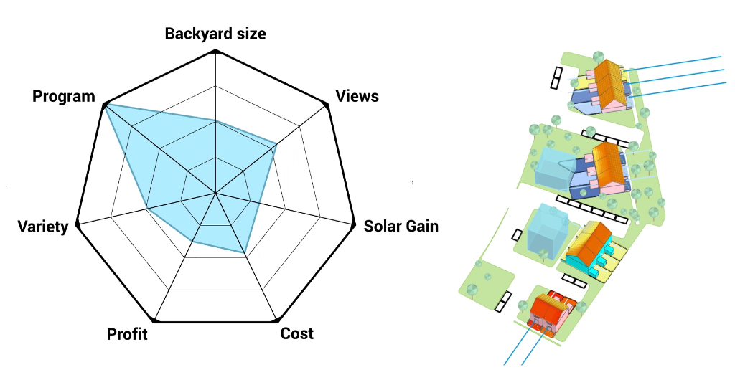 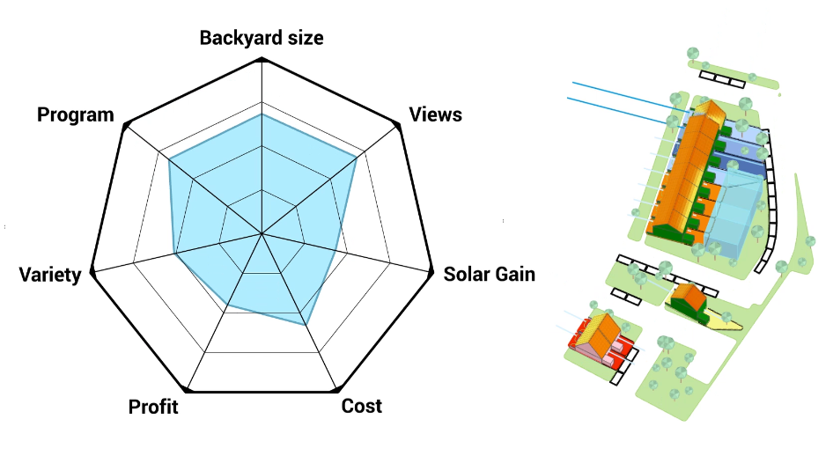 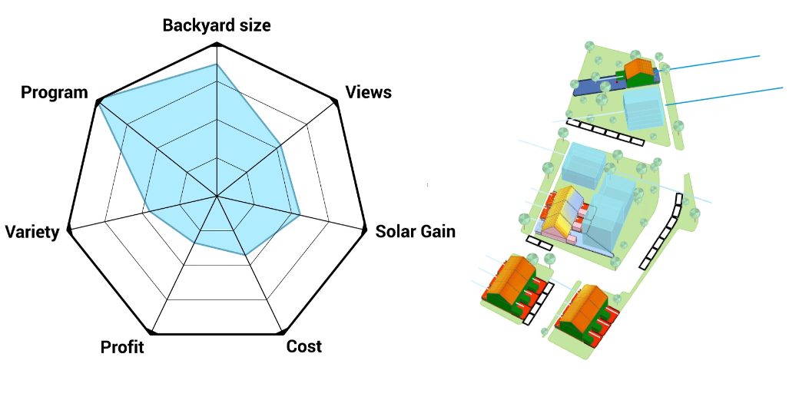

*Van Wijnen Neighborhood design project*

“We want to be able to learn from more designs than it is physically possible to generate or evaluate ‘by hand’.” – Danil Nagy, The Living

### How can I use generative design workflows?

The tools that The Living used to do these studies were custom tools that were not available to the public at the time. Autodesk is interested in democratizing this methodology and in making them accessible to more people. Project Refinery is a beta application Autodesk is developing to help preform generative design workflows like these. Project Refinery:

* Automatically runs Dynamo created logic to create options
* Works on Dynamo for Revit or Dynamo Sandbox
* Created for one customer Van Wijnen in 2/2018
* Public Beta as of 11/2018
* Available at [**autodesk.com/solutions/refinery-beta**](https://www.autodesk.com/solutions/refinery-beta)

The outcome of an automatic design search is completely dependent on the process used to create the design space, as well as the specification of various measures and search parameters. So how do you create a good design space? The traditional architectural design process is similar to the generative design process in many ways. In the traditional architectural design process, you ask for requirements from your client – how big a building do you want? What kinds of spaces to you need in the building? What goals do you have for the design?

This traditional process of identifying goals and requirements is still important when incorporating generative design techniques. With generative design you usually can’t design all aspects of a building in one automated process, you have to identify what kinds of problems might be good to look at in ways that the computer can help you to generate options and evaluate them, but you are still defining goals and measuring success. It’s critical to design how the problem with be generated by the computer and how you will measure success. How are you going to make decisions on the results? The first step is good preparation:

* Understand what you want to achieve
* Define your problem
* Decide on ways to measure success
* Think about how to review the results

Traditional Design process is a little bit like a game of battleship. Ideas are tested one at a time. “Does this work?” “What about this?” You might get a hit, you might get a miss. Often times only a few designs can really be evaluated because you run out of time. Solutions may be presented based on cost only when you really want to show the client more options. With generative design techniques, people and computers work together to created and evaluate more designs.

*“The goal of generative design is not to automate the design process, or to replace human designers with artificial ones”* – Danil Nagy, The Living

### Example 1: Simple Massing Study

Let’s see how some examples of design logic can be created in Dynamo and run through Refinery to learn about generative design workflows. If you are unfamiliar with Dynamo, you can learn more in this Dynamo Primer: <https://primer.dynamobim.org/>

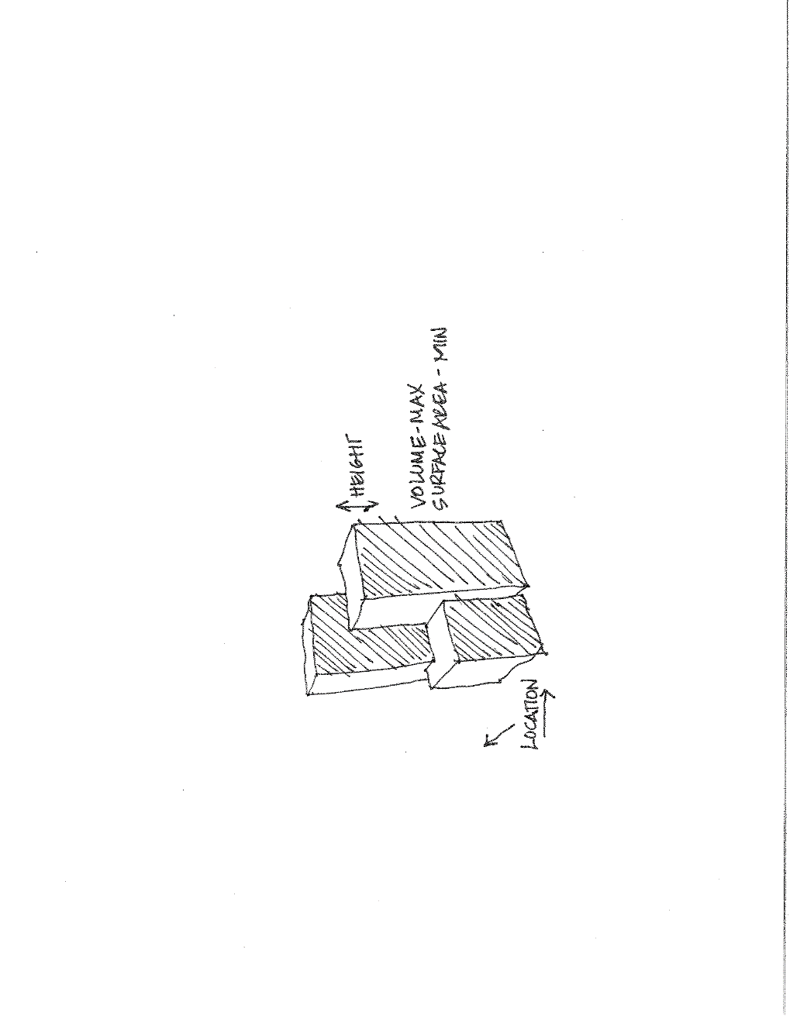The first step with any generative design workflow is to identify what problem we are solving for. In this case we want to study a building mass to look at trade-offs between volume and surface area.

* Variable Inputs:
  1. Locations of 2 of the masses
  2. Heights of all 3 masses
* Goals:
  1. Maximum volume (rentable area)
  2. Minimum surface area (expensive façade)

The Dynamo graph for this study is broken down into 3 sections:

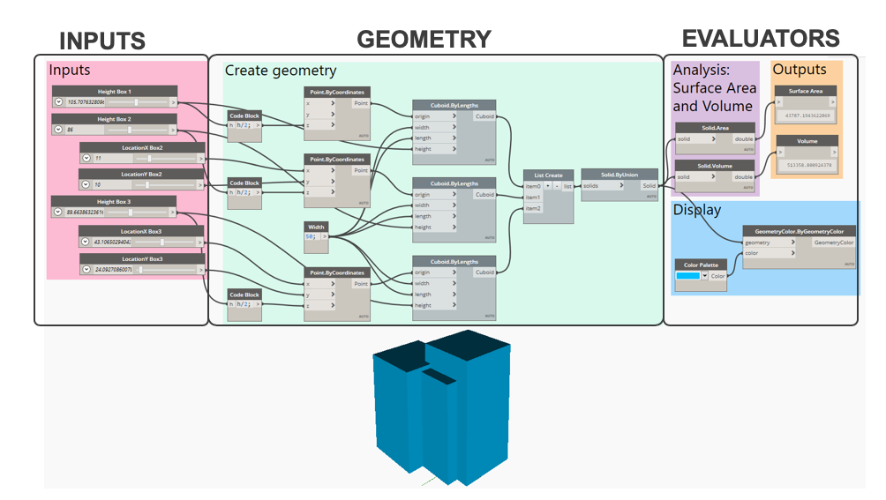

Open the 3Box.dyn sample file in Dynamo and move the sliders in the Inputs section to understand how they are controlling the model. Next, look at the Geometry section to see how the geometry is being created with points and cuboid nodes. Finally, the Evaluator section contains nodes that measure surface area and volume, watches the outputs, and controls the display color of the geometry. There are several stages to the generative design workflow:

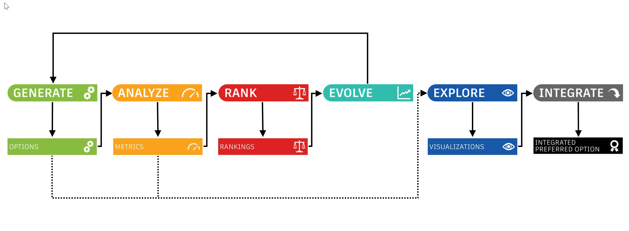

Generative design workflow

Let’s look at some key concepts in each stage.

### Generate

Create a flexible design system in Dynamo to generate designs.

3 key concepts:

* How you parametrize the model is critical
* Too many inputs will lead to a design space that is too big to explore
* Too few inputs won’t yield a big enough design space

The flexible system in the 3Box.dyn model is very simple. The Inputs in the pink group control point locations for the cuboids in the geometry section of green groups. As well as the cuboid locations, the inputs also control the height of the cuboids.

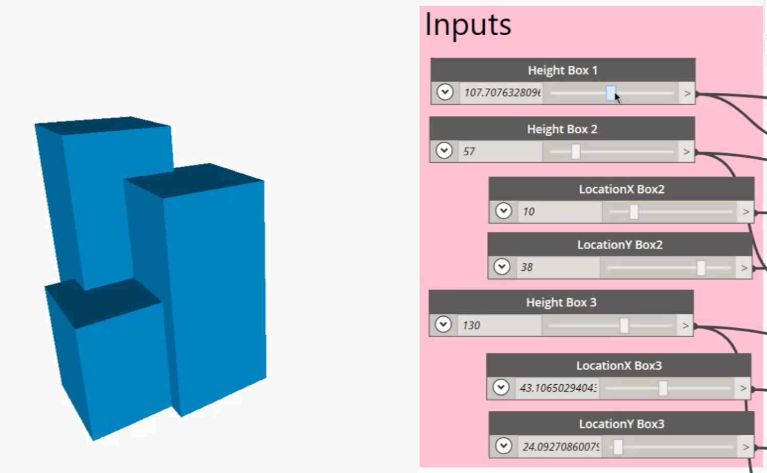

3Box.dyn Inputs

In the green geometry creation section, there are 3 points, that place 3 cuboids. Once placed, the 3 cuboids are unioned together to form a single piece of geometry.

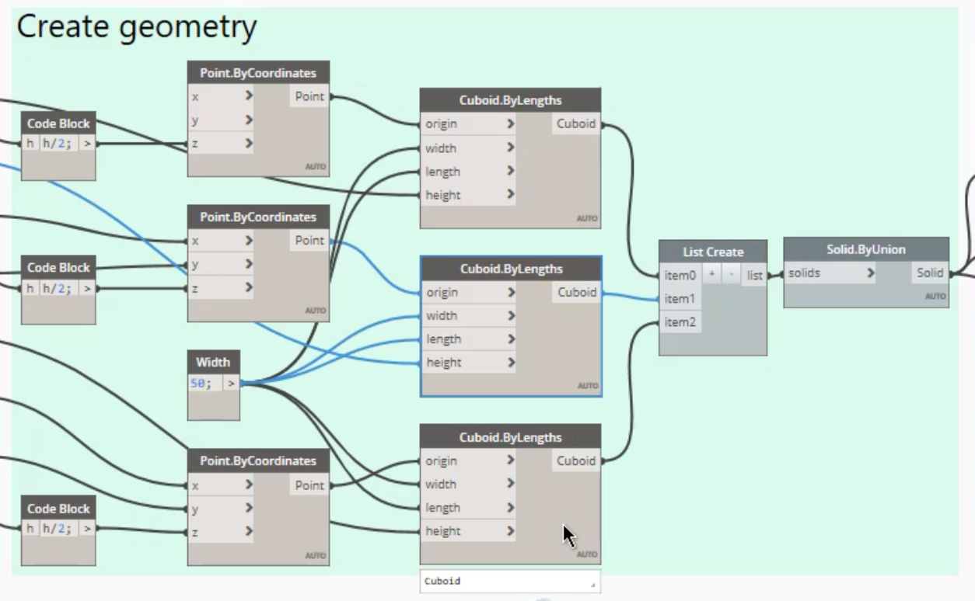

Geometry creation section of 3Box.dyn

The next sections involve analyzing the resultant geometry for surface area and volume, watching the outputs, and controlling the display color of the geometry.

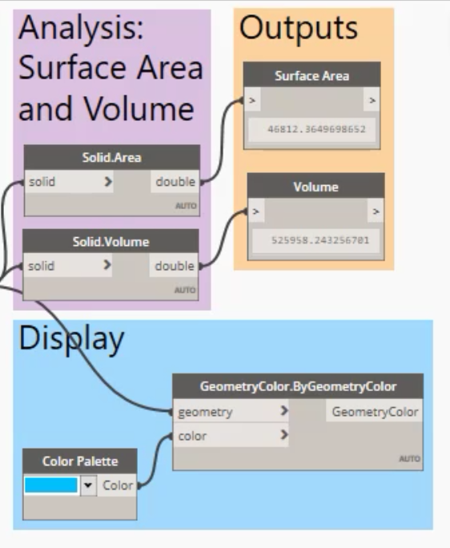

Analysis, Display and Outputs of 3Box.dyn

Now that we have a design system defined, we can use Refinery to automate or generate the creation of design alternatives that exist in the design system. Generation methods in Refinery include:

1. **Randomize** When Refinery uses the Randomize option it will generate a specified number of design options, by randomly assigning a value to each of the input parameters. This option is used when facilitating an optioneering process.

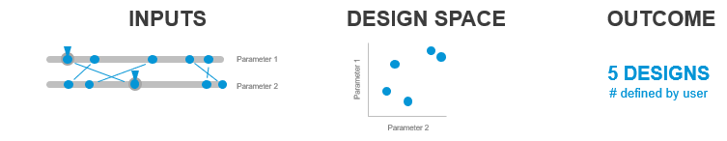

1. **Optimize** is the method for doing an optimization run with Refinery. During an optimization run Refinery will evolve the design based on the evaluators outputs. The optimization process works by running multiple generations of a design, each generation will use the input configuration from previous generations and from that optimize the new design options.

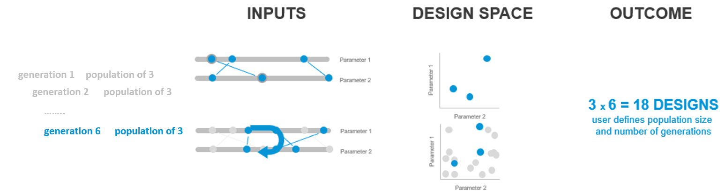

1. **Cross Product** method let's you explore the entire design space of your design, by combining each step of every parameter with the remaining parameters.

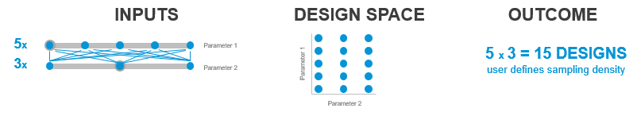

1. **Like This** will make Refinery apply slight variations to your current input configuration. Using this method lets you explore different variations of a design that you already like.

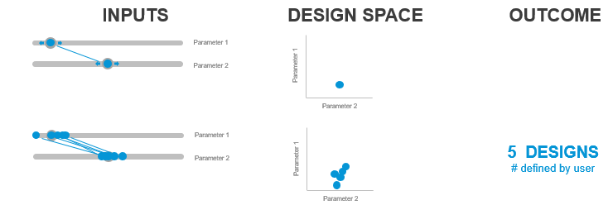

Refinery can be run using the different methods above. In the Refinery window you can choose from the four different methods.

**How to run an optioneering process using Refinery**

An optioneering process lets you explore all possible solutions that the graph can produce. This is helpful if you want to test the flexibility of the graph or you’re unsure about what to optimize for. Refinery will generate the solutions based on the constraints that were defined in the Dynamo graph. To run an optioneering process in Refinery, follow these steps:

1. 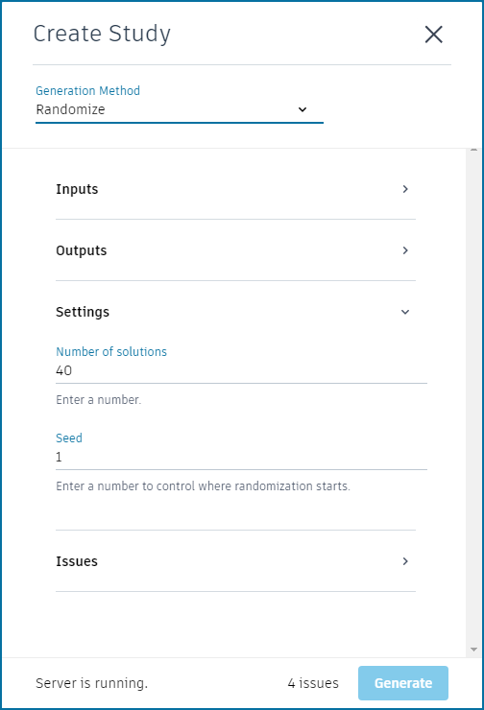Launch Refinery from the Refinery menu in Dynamo
2. Create a new study and select Randomize, Cross Product or Like This as the generation method
3. Under Inputs make sure that all the desired inputs are present
4. For inputs that should not change on each run, set the desired value and uncheck the box alongside it
5. Under Outputs ensure each output defined in the graph is listed
6. Under Settings choose how many options Refinery should create
7. Under Settings select a random seed (number) to initialize the randomization
8. Under Issues resolve any items
9. Click Generate

**How to run an optimization process using Refinery**

An optimization process lets Refinery evolve your design to find the most suitable options based on the constraints and goals provided. Refinery will run multiple generations of options and each time it will take the fittest (best) options of the generation and use them to create a new generation. Refinery is using [NSGA-II](https://www.iitk.ac.in/kangal/Deb_NSGA-II.pdf), an ‘elitist’ multi objective genetic algorithm to optimize results. To run an optimization process in Refinery, follow these steps:

1. 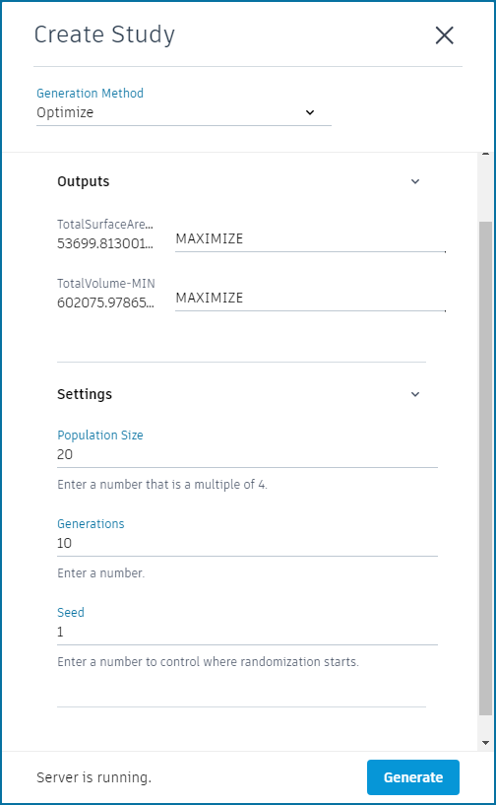Open Refinery from the Refinery menu in Dynamo
2. Create a new study and select Optimize as the generation method
3. Under Inputs make sure that all the desired inputs are present
4. For inputs that should not change on each run, set the desired value and uncheck the box alongside it
5. Under Outputs go through each objective and set the optimization goal you want to achieve - Maximize, Minimize, or Ignore
6. Under Settings set a population size, which represents the number of options that will be created in each generation.
7. Under Settings set the amount of generations you want to create. Each new generation is a range of options that falls between the two best designs of the previous generation
8. Click Generate

### Analyze

Judging outcomes is the critical 2nd half of the problem. To do this you can use a set of measures that determine how the building is performing. Why?

* + Compare designs objectively (apples to apples)
  + Evaluate designs based on non-intuitive measures
  + Explore more designs than is possible manually

There are 3 types of measurement:

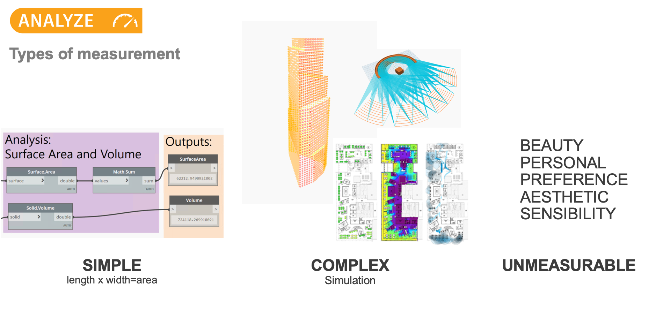

Designating inputs and outputs in Dynamo for use in Refinery: 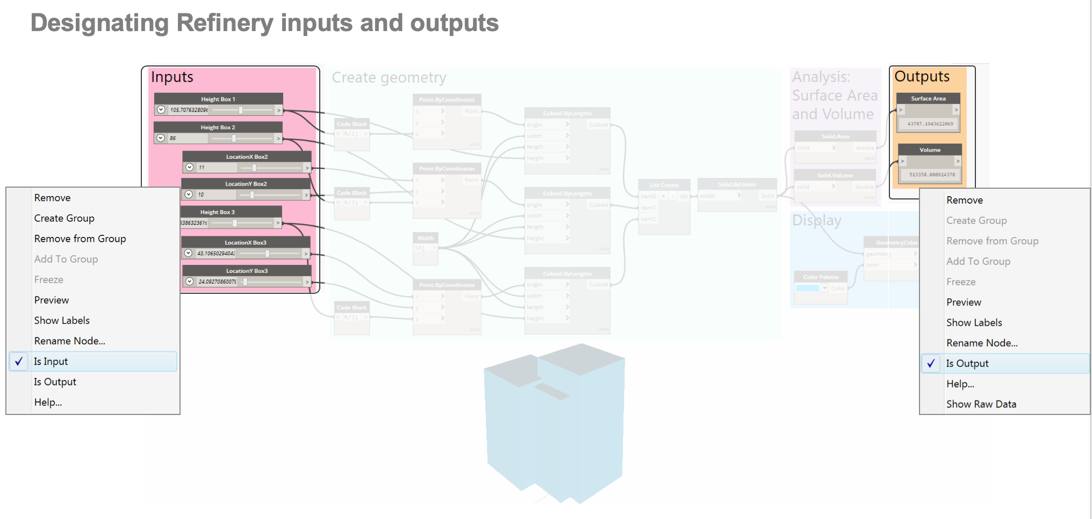

### Rank

In Refinery, you can use sorting and filtering to rank resultant design options and make decisions about the best options for your needs.

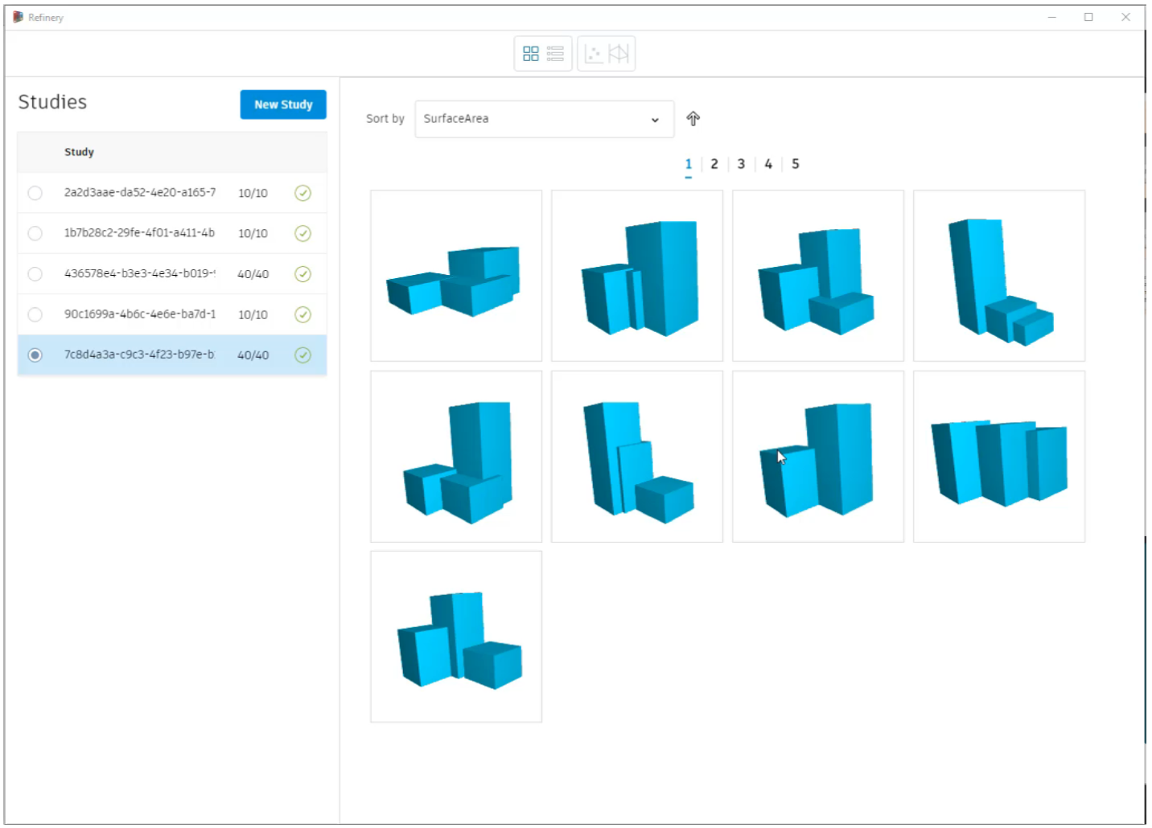

Refinery designs sorted by Surface Area

### Evolve

After you have explored some possibilities in the design space that you have set up in Dynamo, you may want to set some goals for the design to guide the design generation and produce options that meet your goals. To do this, you can use the Optimize generation method. There are several parameters that effect the optimization

* + Output goals (maximized or minimized)
  + Population size (how many designs should be tested in each generation?)
  + Generation size (how many generations should be tested?)
  + Seed (initialization value)

Optimization runs can take longer, but will return only results that meet your goals. The runs below show the difference between the Random method and the Optimization method. The scatter plot charts below are both set to Volume on the Y-axis and Surface Area on the X-axis. Note that in the optimization run on the right, the designs return look much more similar and form a tighter line comparing volume and surface area.

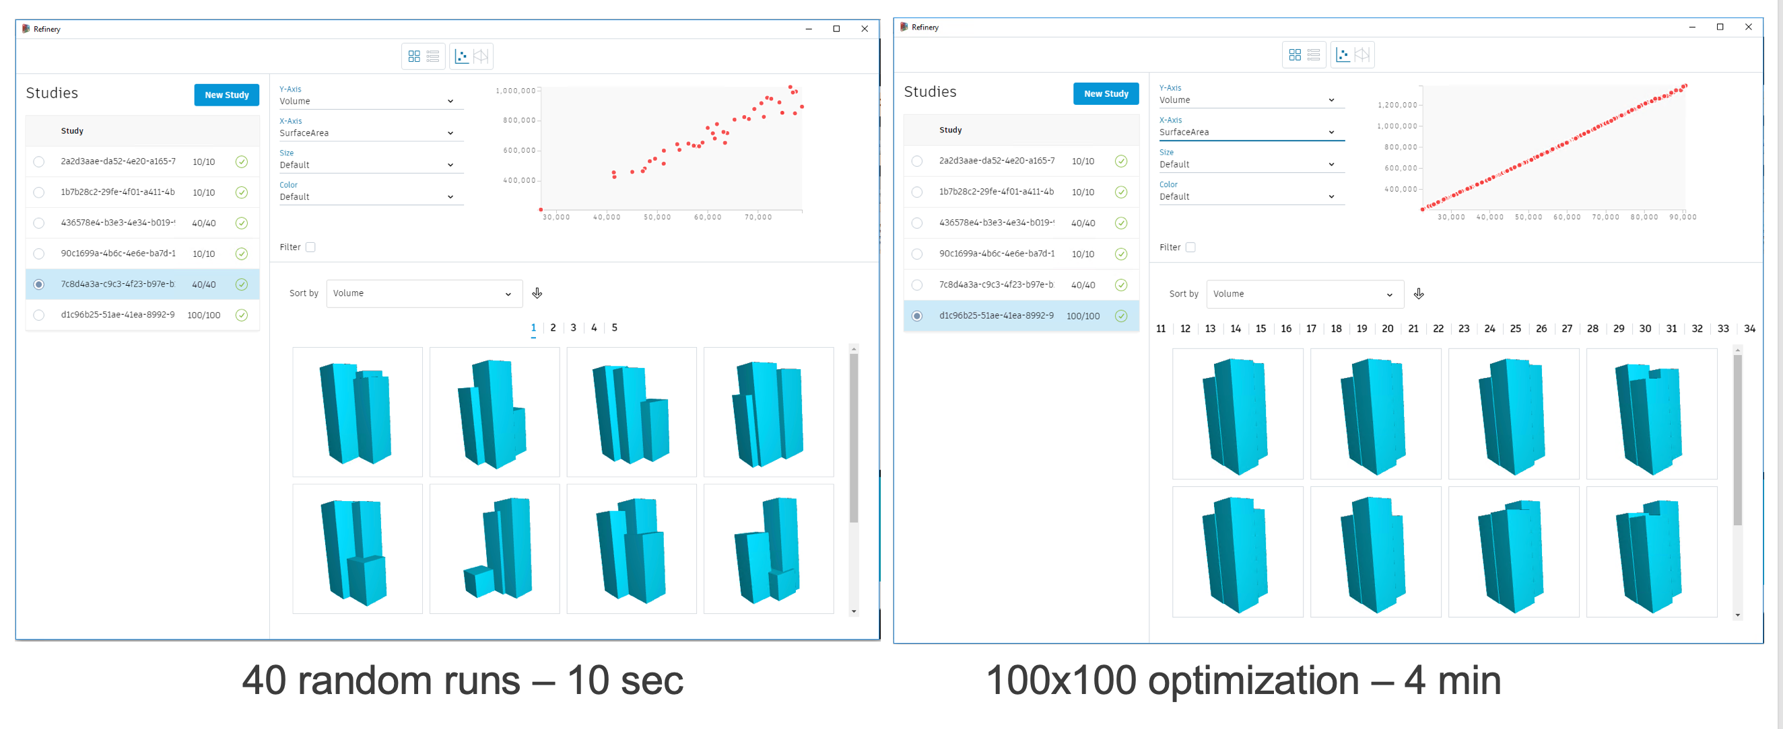

### Explore

After Refinery has run the generative process, the results are displayed in both geometric form and through a series of charts or tables. All of the resulting views are interlinked and selecting an option in one view will highlight it in the other views currently displayed. If Dynamo is running in Automatic mode in the background, selecting an option will also update the graph to show this design. There are several features of the explore interface:

1. **Design Grid** The design grid shows each option as a 3d geometrical thumbnail that can be individually rotated, zoomed and panned to explore the design in more detail. The order of the thumbnails can be sorted based on the inputs or outputs of the Dynamo script, with a toggle for both ascending and descending values.

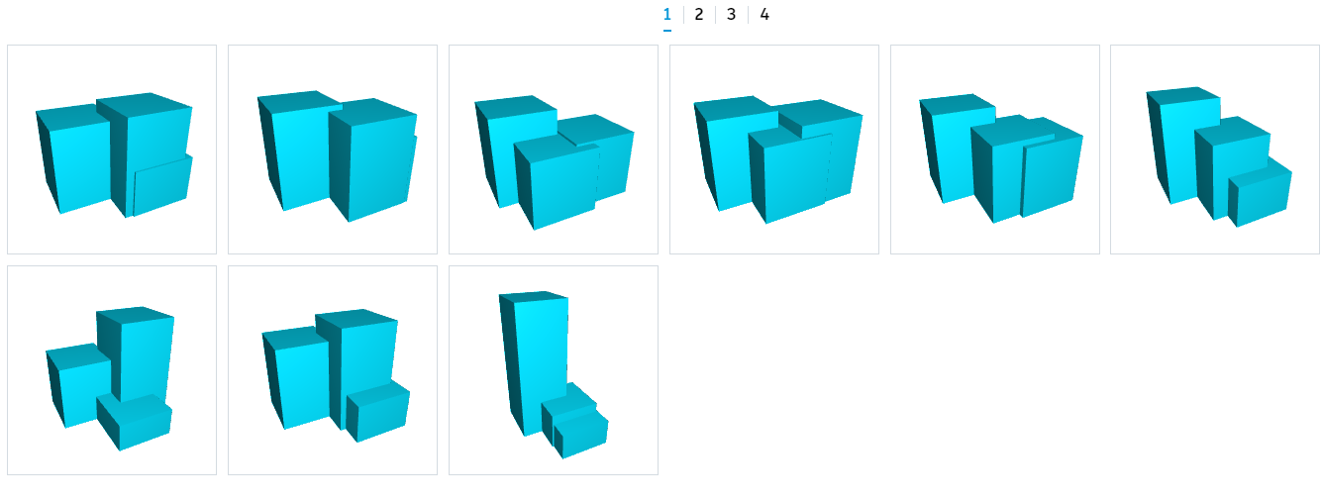

1. **Design Table T**he design table replaces the design grid, if chosen, and lists each option in a table form with each column representing the values for the inputs and outputs.

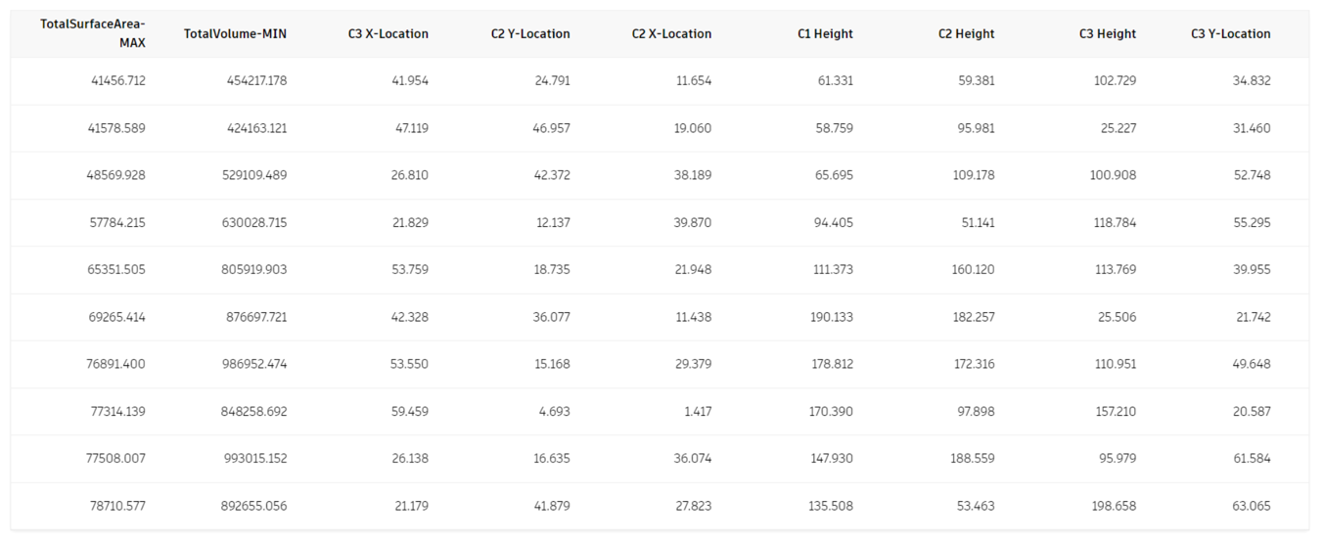

1. **Scatterplot** The first chart Refinery uses to visualize data is a Scatterplot : a type of mathematical diagram that uses cartesian coordinates to display values across a set of data. Refinery allows you to select what values are displayed along both the X and Y axis as well as which ones drive the size and color of the circles in this 4-dimensional view. The values can be chosen from the inputs or outputs you defined in the Dynamo graph in the previous steps. Selecting a circle from the graph space will also highlight the chosen option in the design grid or design table.

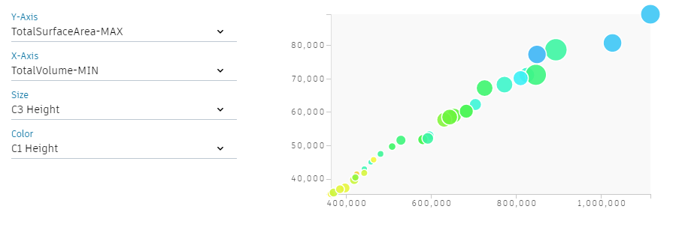

1. **Parallel Coordinates T**he other chart available in Refinery is a Parallel Coordinates graph. This chart shows a set of vertical parallel lines, equally spaced, that represent the inputs and outputs. Each design option is represented as a polyline whose vertices sit on each parallel axis. The position of the polylines vertices on the axis corresponds to the value of the input or output. The graph can be filtered by dragging the selection on each vertical axis.

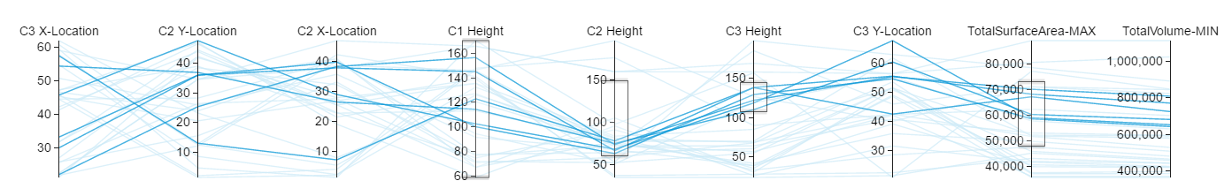

The kind of visualization you choose for your project may vary depending on what kind of process you are running. If you are running an optioneering process, it can be beneficial to visualize it using a parallel coordinates chart as it will be easier to filter options, while visualizing a multi-objective optimization using a scatterplot chart will make it easier to find the best trade-off between two objectives.

### Integrate

The final step in the generative design workflow is to integrate your chosen design into a context where you can develop it further. One way to do this is to add a branch to your Dynamo graph which places Revit elements. In this example we’re first adding floors to the Dynamo model for a more detailed analysis of the occupiable space.

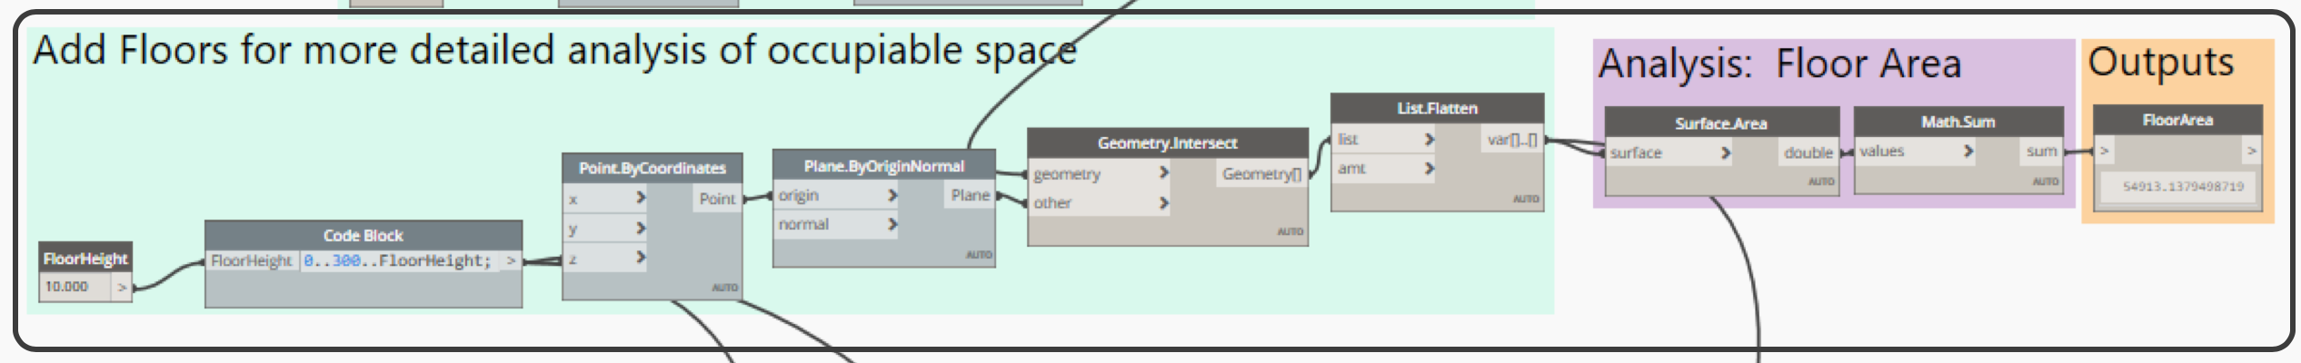

And then we can add those same floors to the Revit model.

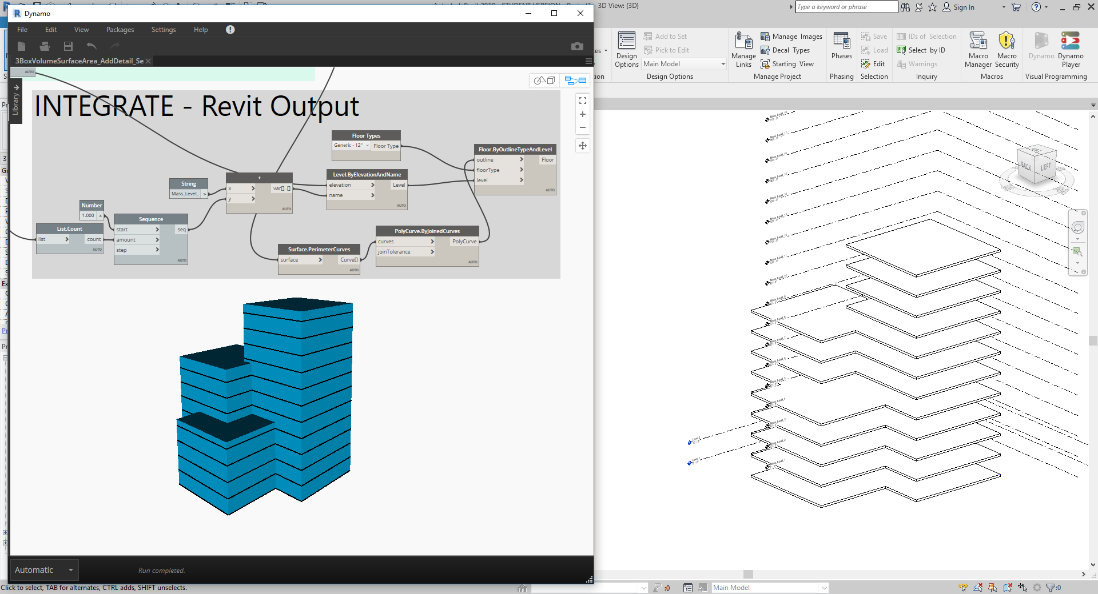

Integrate design data into Revit as floors.

### Example 2: 2d Hill Climbing

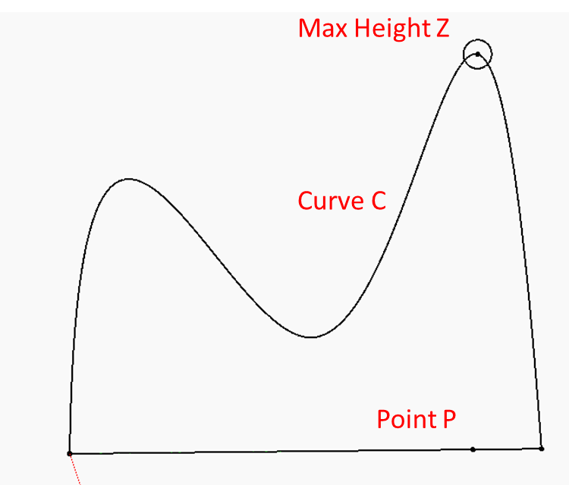Let’s go back a step and focus goal-setting and how to make evaluators.

This study looks goes back to the basics and helps us define what an evaluator is, and how to describe objective functions to be maximized or minimized

* Variable Inputs:

1. Curve C
2. Point P

* Goals:

1. Find Maximum Height Z for Point P

### So What is an Evaluator?

An evaluator (also known as a discriminator), is fed potential solutions from the generator and evaluates how good or bad these solutions are. Evaluators are a natural analogue of the objective and fitness functions outlined below. In a generative building design, an evaluator may be a function that describes the average amount of sunlight a façade will be exposed to over a year.

In design, evaluators must be specified mathematically, they must output a number that can be used to discriminate between solutions.

* <https://refineryprimer.dynamobim.org/05-algorithms/05-03_evaluators>

### The Evaluation Phase

What do you mean by an ‘objective function’?

An objective function is simply the criterion you want to maximize or minimize.

What do you mean by ‘fitness’?

A fitness function is essentially the objective function for the genetic algorithm; it's the criterion you want to maximize or minimize, the thing you care most about achieving. A fitness function is used to evaluate how close (or far) a given design solution is from achieving the designer’s goals. The genetic algorithm is designed to drive the model to higher and higher fitness, so defining a fitness function precisely and accurately is vital.

Some examples of fitness functions that could be used in a Generative Design context include:

* Maximize hours of daylight for each desk in an office
* Maximize circulation in common areas
* Minimize number of distinct types of parts needed to assemble an object
* Minimize number of total parts needed to assemble an object
* Maximize the structural strength of a critical component in a product
* Minimize the fuel needed to power a vehicle
* Minimize the weight of a design

You can see here that these suggestions are always framed as either a maximization or minimization problem. As discussed above, this formulation is crucial for an optimization approach to be effective.

Another consideration is that it is desirable for fitness functions to be calculated very efficiently by a computer. That is, a good fitness function can be calculated fast. With experience, a user comes to learn which kinds of fitness functions are likely to be particularly fast or slow.

One of the great strengths of a genetic approach is that the fitness function can be quite complicated. In fact, a single genetic model can have multiple competing fitness functions or even a single fitness function that is a combination of several others (minimize the weight of a design while also making it as structurally sound as possible, for example). This is also known as Multi Objective Optimization and Single Objective Optimization.

* <https://refineryprimer.dynamobim.org/04-optimization/04-08_the-evaluation-phase>

Objective Function for our 2d Hill Climber

* Find Maximum Height Z for Point P
  + 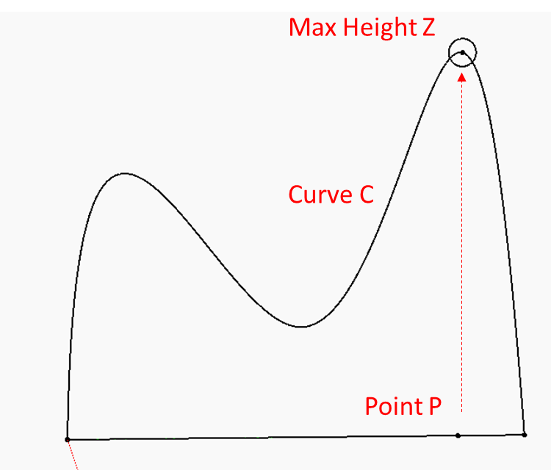z = f(c,p)
  + maximize z
* Variable Inputs:
  + Curve C
  + Point P
* Objective Function:
  + z = f(c,p)
  + Find maximum height
  + f(c,p) =
    - Projected Point P’ = P.Project(C)
    - Height Z = P’.z
    - x = P.x

Here is the end state of the Dynamo Graph:

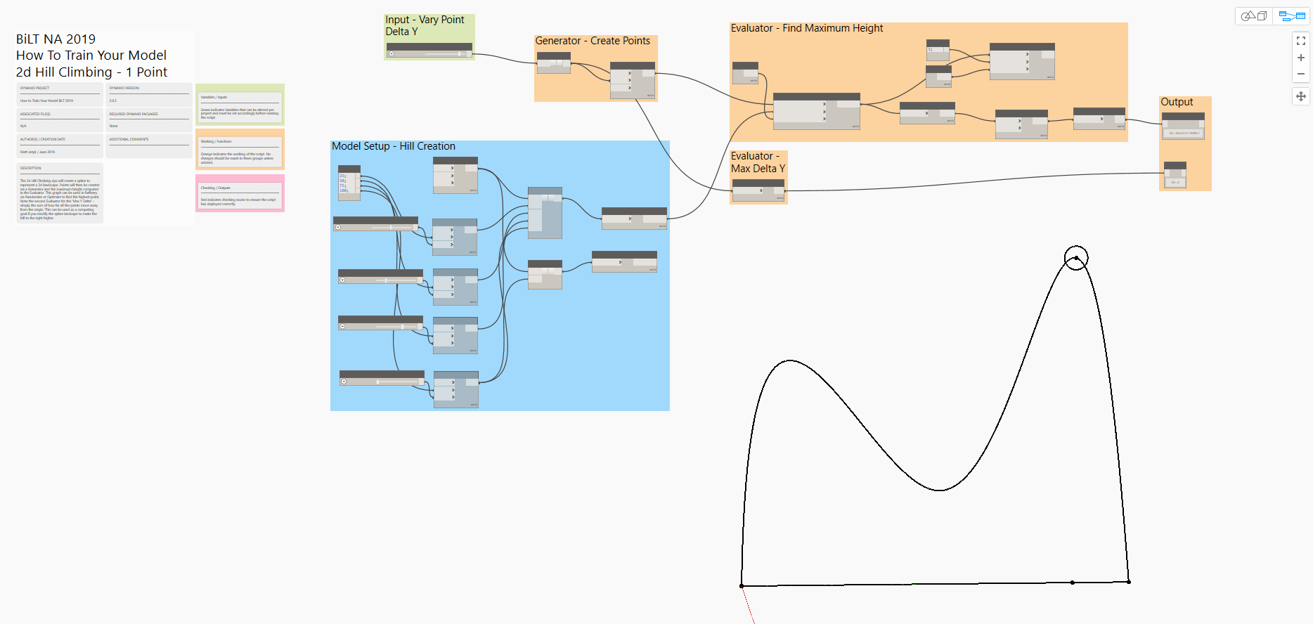

You can see the nodes in the blue group set up the 2d hill. We have a Generator that lays out points along the base line, simply by making a range of points and varying their Z value. The Evaluator is set up to project the base points up to the hill curve. It then adds up all the Z heights and passes that to the Output section. Here is the Evaluator:

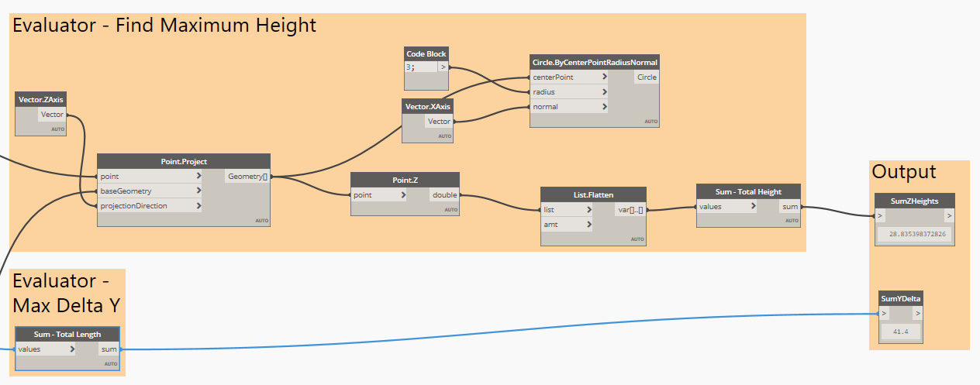

If you open the “2d Hill Climbing 1 point START.dyn”, you should see the rest of graph. Let’s build up the evaluator together to look like the image above.

Also note the description in the notes on the left:

The 2d Hill Climbing dyn will create a spline to represent a 2d landscape. Points will then be created via a Generator and the maximum height computed in the Evaluator. This graph can be used in Refinery via Randomize or Optimize to find the highest point. Note the second Evaluator for the 'Max Y Delta' - simply the sum of how far all the points move away from the origin. This can be used as a competing goal if you modify the spline landscape to make the hill to the right higher.

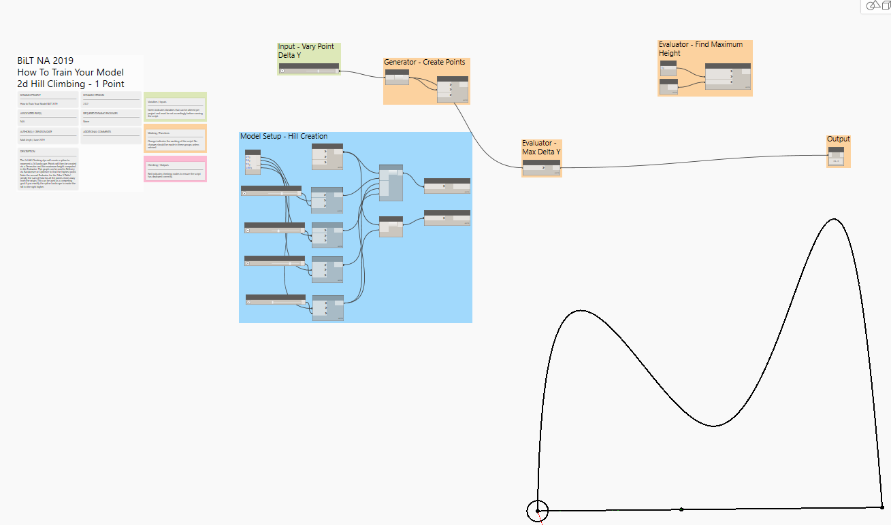

Build the Evaluator and also add a Watch node labelled “SumZHeights”, making sure to set the ‘IsOutput’ setting on the node so Refinery knows to use it. Once we have built the Evaluatorand the Output we can open Refinery and Generate some options!

Let’s use Randomize first. You will notice the results look very similar to the 2d hill in dynamo because we are simply plotting y values for the range of x values being tested.

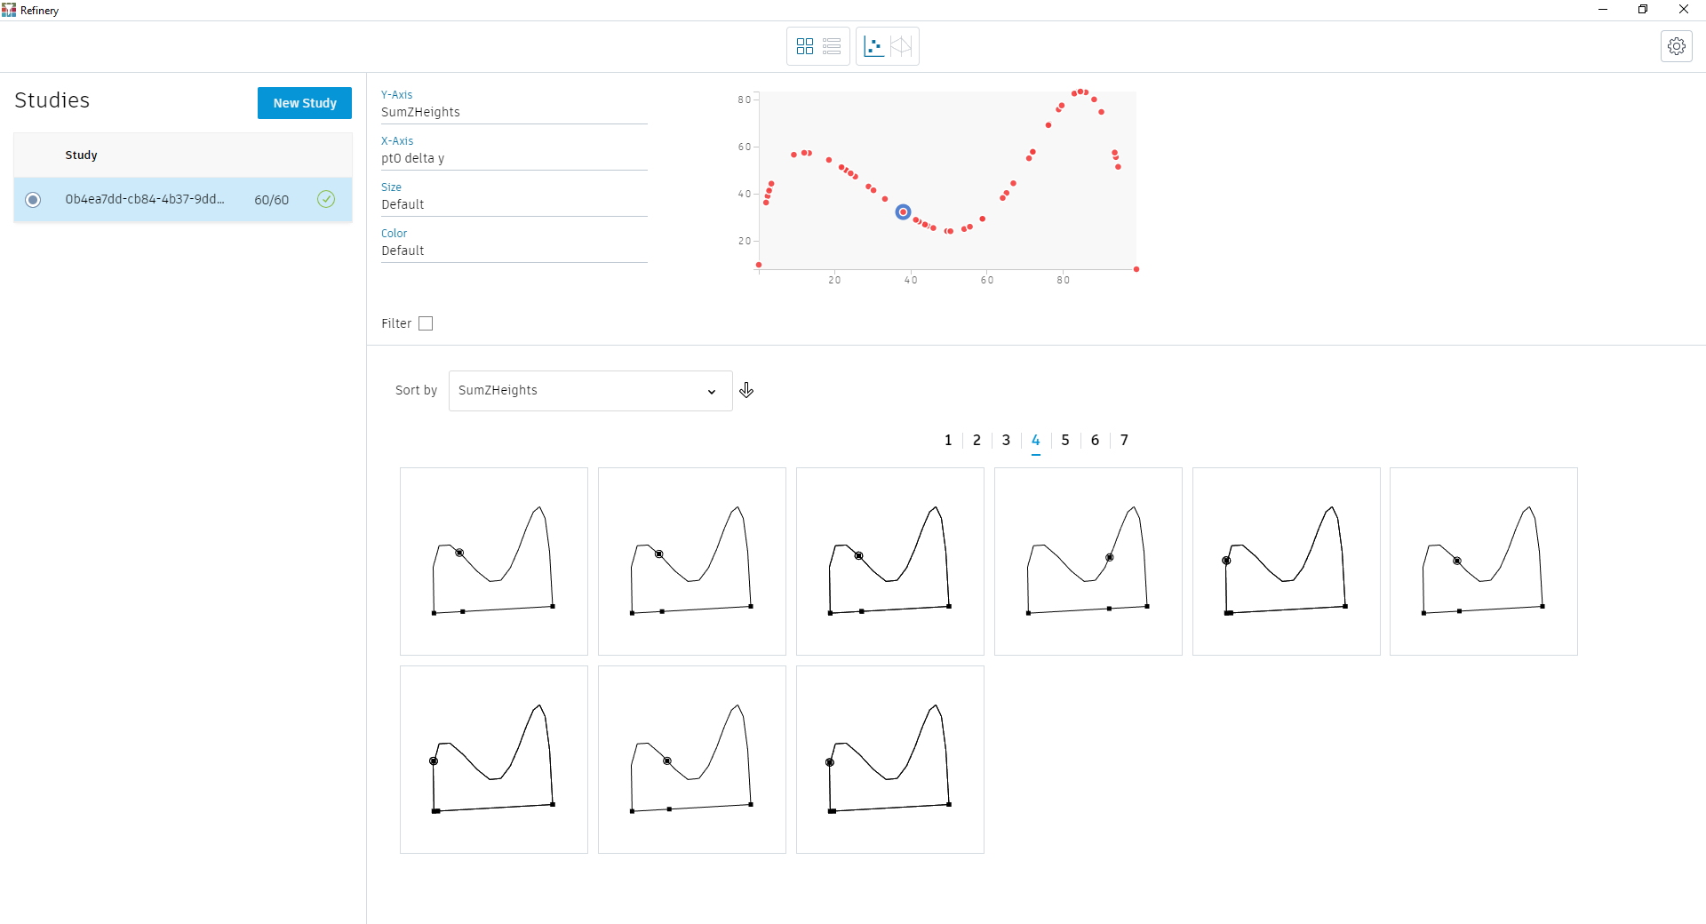

Now let’s try an Optimize run, you should see results similar to this:

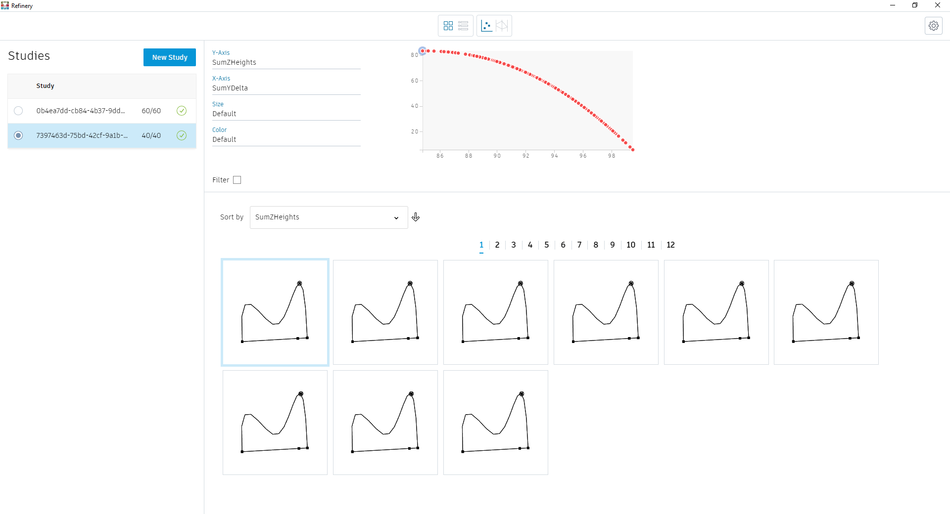

You can add more inputs to the graph, simply by adding more sliders and wiring them up to the List node. Make sure to set the sliders to ‘IsInput’ and give them unique names,

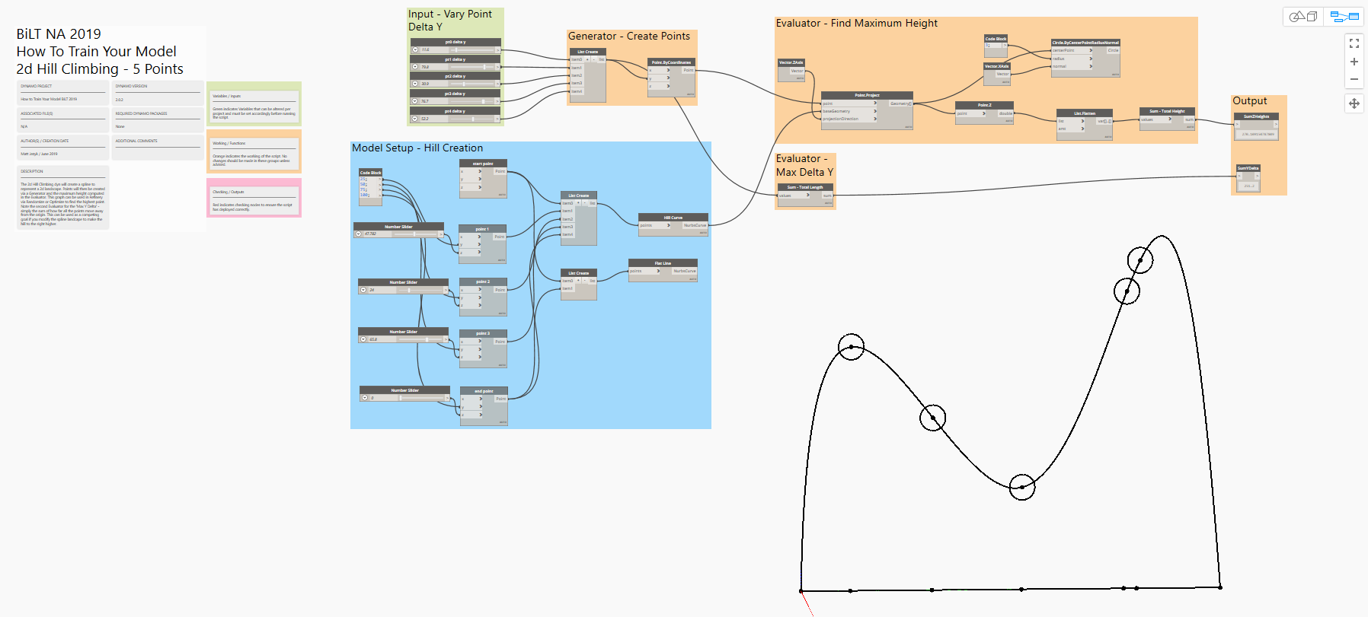

Notice what happens when you run Optimize on this graph? You should start to see the Pareto front develop.

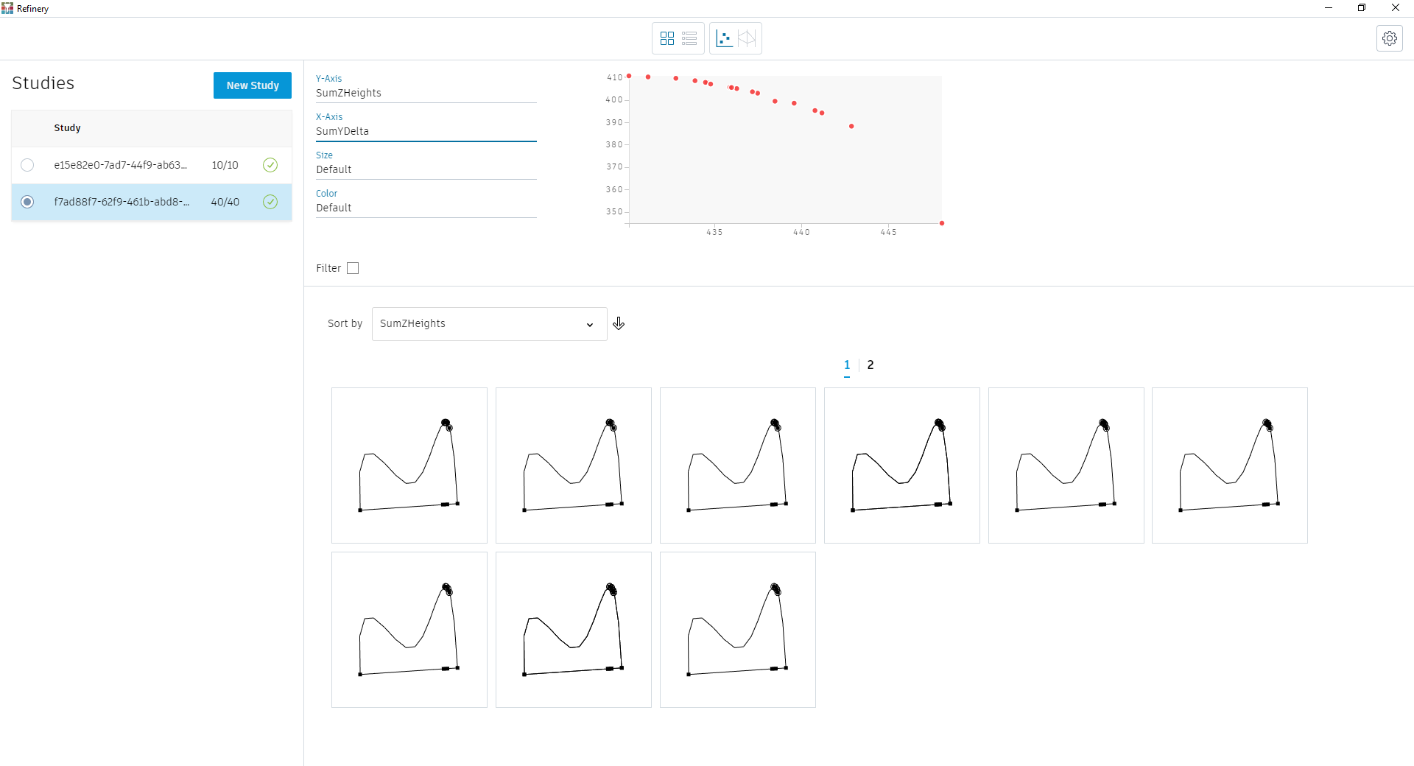

Now modify the shape of the hill by altering the sliders in the blue group.

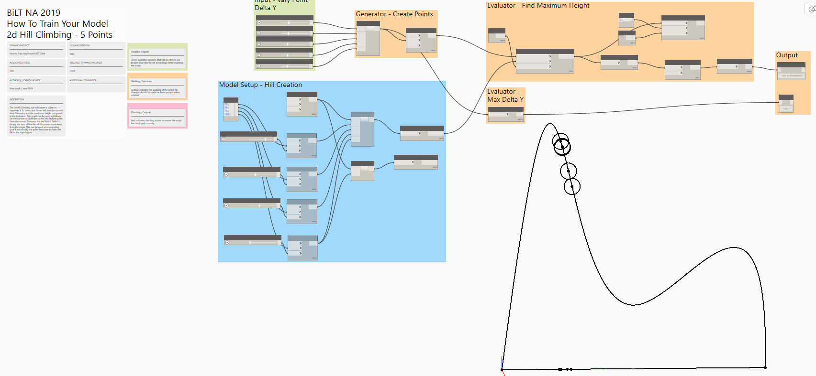

If you run Refinery again you can solve for the new hill condition. You can also see how competing goals can play out. The Maximize Z and Maximize Y goals are competing:

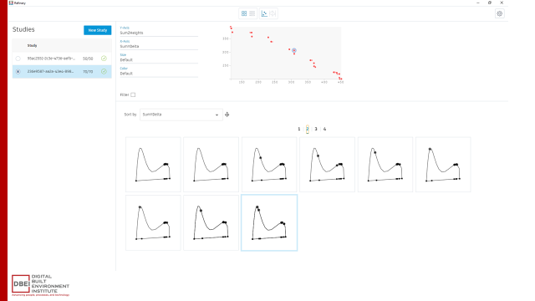

We can create the same type of Evaluator using DesignScript and Python. For Designscript, simply in the interest of time, select the nodes and find the ‘Node to Code’ option in the right click menu:

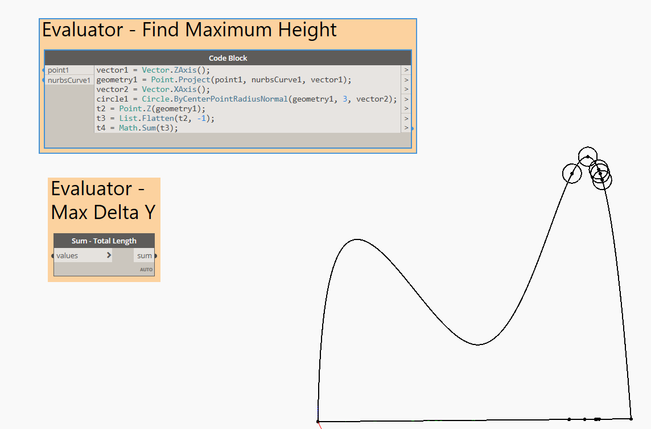

You can use DesignScript for much more than this, of course, but for the next excerize we will use Python instead.

We will use Python to make a new Generator to create many more points than we would want sliders for, then start to control them with a new Evaluator.

Open the file, “2d Hill Climbing N points python local solver slope START.dyn”

Start by double-clicking on the node called ‘PointGenerator’. This is a Python node we will add code to.

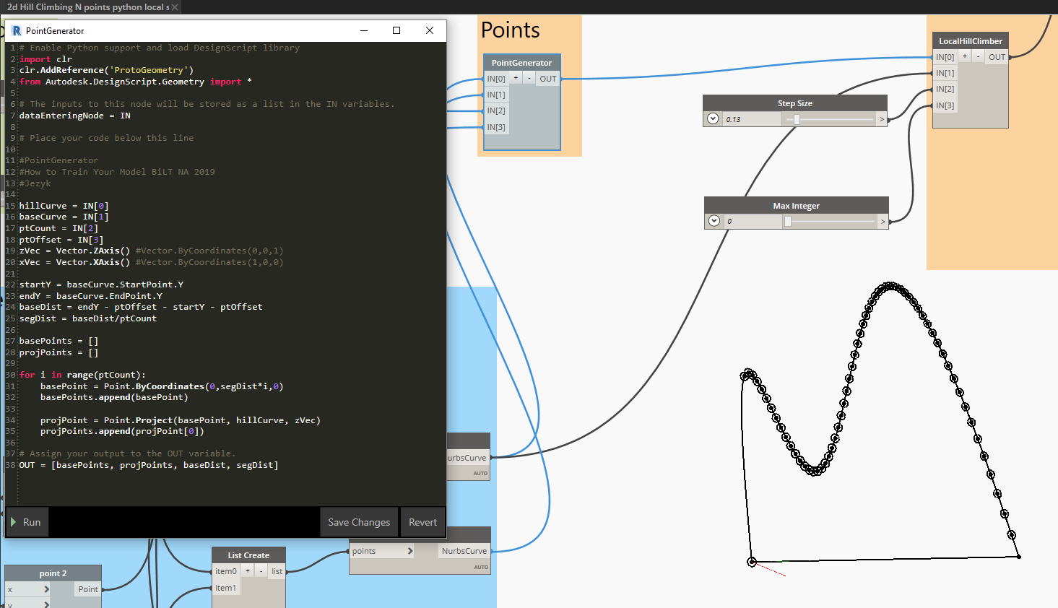

Enter this code:

# Enable Python support and load DesignScript library

import clr

clr.AddReference('ProtoGeometry')

from Autodesk.DesignScript.Geometry import *

# The inputs to this node will be stored as a list in the IN variables.

dataEnteringNode = IN

# Place your code below this line

#PointGenerator

#How to Train Your Model BiLT NA 2019 - Jezyk

hillCurve = IN[0]

baseCurve = IN[1]

ptCount = IN[2]

ptOffset = IN[3]

zVec = Vector.ZAxis() #Vector.ByCoordinates(0,0,1)

xVec = Vector.XAxis() #Vector.ByCoordinates(1,0,0)

startY = baseCurve.StartPoint.Y

endY = baseCurve.EndPoint.Y

baseDist = endY - ptOffset - startY - ptOffset

segDist = baseDist/ptCount

basePoints = []

projPoints = []

for i in range(ptCount):

basePoint = Point.ByCoordinates(0,segDist*i,0)

basePoints.append(basePoint)

projPoint = Point.Project(basePoint, hillCurve, zVec)

projPoints.append(projPoint[0])

# Assign your output to the OUT variable.

OUT = [basePoints, projPoints, baseDist, segDist]

And then press Run, you should see points be laid out along the curve.

Now let’s add the Evaluator, double-click on the node named “LocalHillClimber”. This is a Python node we will add code to. Add this code:

# Enable Python support and load DesignScript library

import clr

clr.AddReference('ProtoGeometry')

from Autodesk.DesignScript.Geometry import *

# The inputs to this node will be stored as a list in the IN variables.

dataEnteringNode = IN

# Place your code below this line

#How to Train Your Model BiLT NA 2019 - Jezyk

#Using Newton's Method to find minimum slope along a curve,

#then moving point locations closer to the min slopes based on maxIterations

#you could make this a while loop that continues to iterate until all points are under a min slope.

#Newton's Method in Python

#http://code.activestate.com/recipes/578419-newtons-method-to-solve-equations-in-python/

generatedPoints = IN[0]

hillCurve = IN[1]

pointsOnHill = generatedPoints[1] #[0] = basePoints, [1] = projPoints

step = IN[2]/100

maxIterations = IN[3]

zVec = Vector.ZAxis()

yVec = Vector.YAxis()

xVec = Vector.XAxis()

paramsOnHill = []

vectorsOnHill = []

slopesOnHill = []

projCircles = []

zValues = []

newPointsOnHill = []

#Newtons' Method

#Eval Position on Curve, Return Height

def f(t): # for t (t param of curve), return y height for the curve

    evalPoint = hillCurve.PointAtParameter(t)

    z = evalPoint.Z

    #zValues.append(y)

    return z

#Eval Tangent on Curve, Return Slope

def f_prime(t): # for t (t param of curve), calc tangent and return slope angle of tangent line

    tanVector = hillCurve.TangentAtParameter(t)

    #tanVectors.append(tanVector)

    slopeAngle = Vector.Dot(tanVector, Vector.ZAxis()) #zVec #Vector.XAxis())

    return slopeAngle

#Use Newtons' Method to Step Along Curve

def newtCurve(tParam, n, hillCurve, step):

    for i in range(n):

        if abs(f_prime(tParam)) < 0.5:

            return tParam

        tParam = tParam - ((f_prime(tParam + step)) - (f_prime(tParam - step)))/f_prime(tParam)

        #tParam = tParam - ((f(tParam + step)) - (f(tParam - step)))/step*10

        slopesOnHill.append(f_prime(tParam))

        zValues.append(f(tParam))

    return tParam

#Iterate Through All Points and Move Along Curve

for pt in pointsOnHill:

    paramOnHill = Curve.ParameterAtPoint(hillCurve, pt)

    n = int(maxIterations)

    newT = newtCurve(paramOnHill, n, hillCurve, step)

    pt = Curve.PointAtParameter(hillCurve, newT)

    projCircle = Circle.ByCenterPointRadiusNormal(pt, 3, xVec)

    projCircles.append(projCircle)

OUT = [slopesOnHill, newPointsOnHill, projCircles] #pointsOnHill,

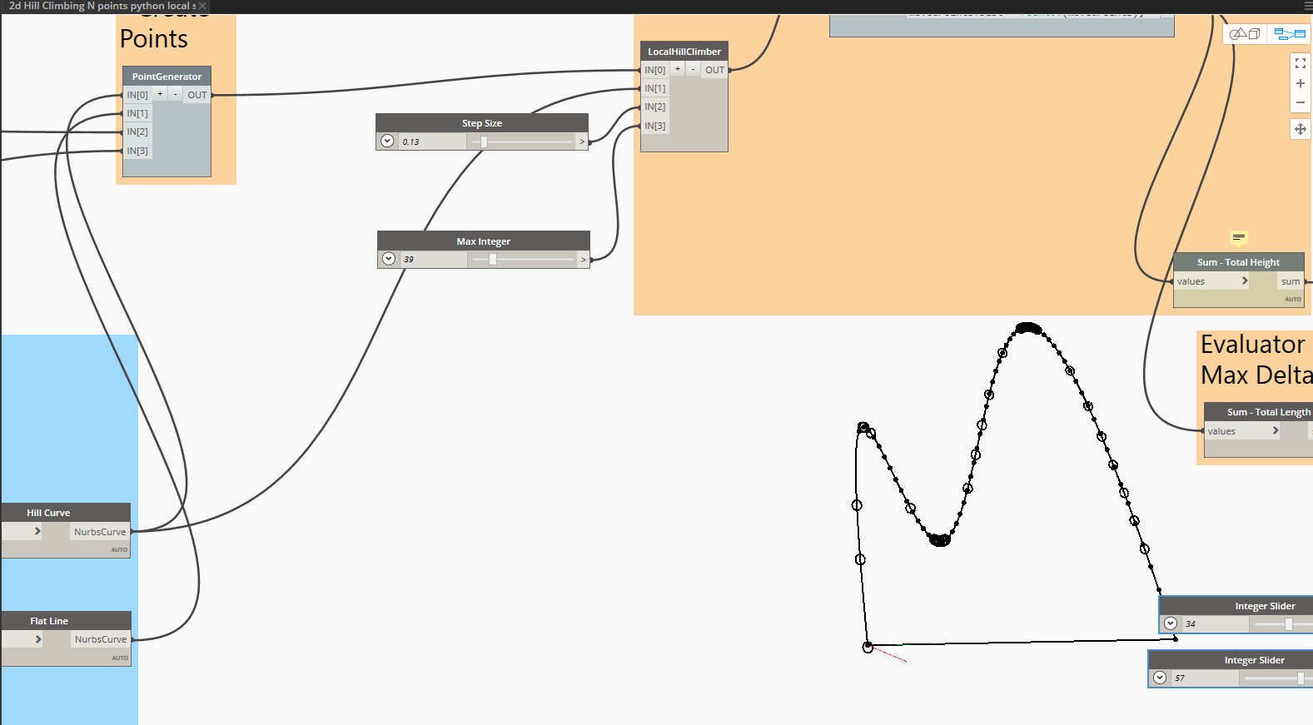

### Example 3: Building Massing – Complex

This study looks at the retail and office distribution and configuration for a building on an urban site.

* Variable Inputs:

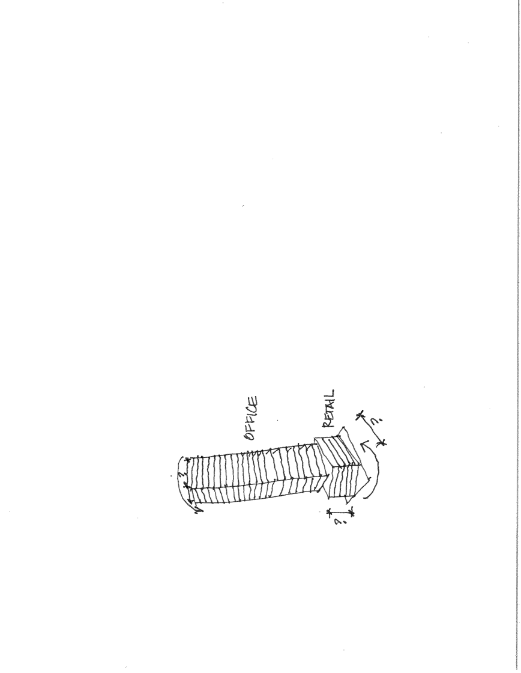1. Ratio retail to office

2. Program block size

3. Program block rotation

* Goals:

1. Minimize zoning envelop overlap

2. Minimize cost

3. Maximize total value per year

The graph contains the same groupings as our previous example, just with a bit more complexity.

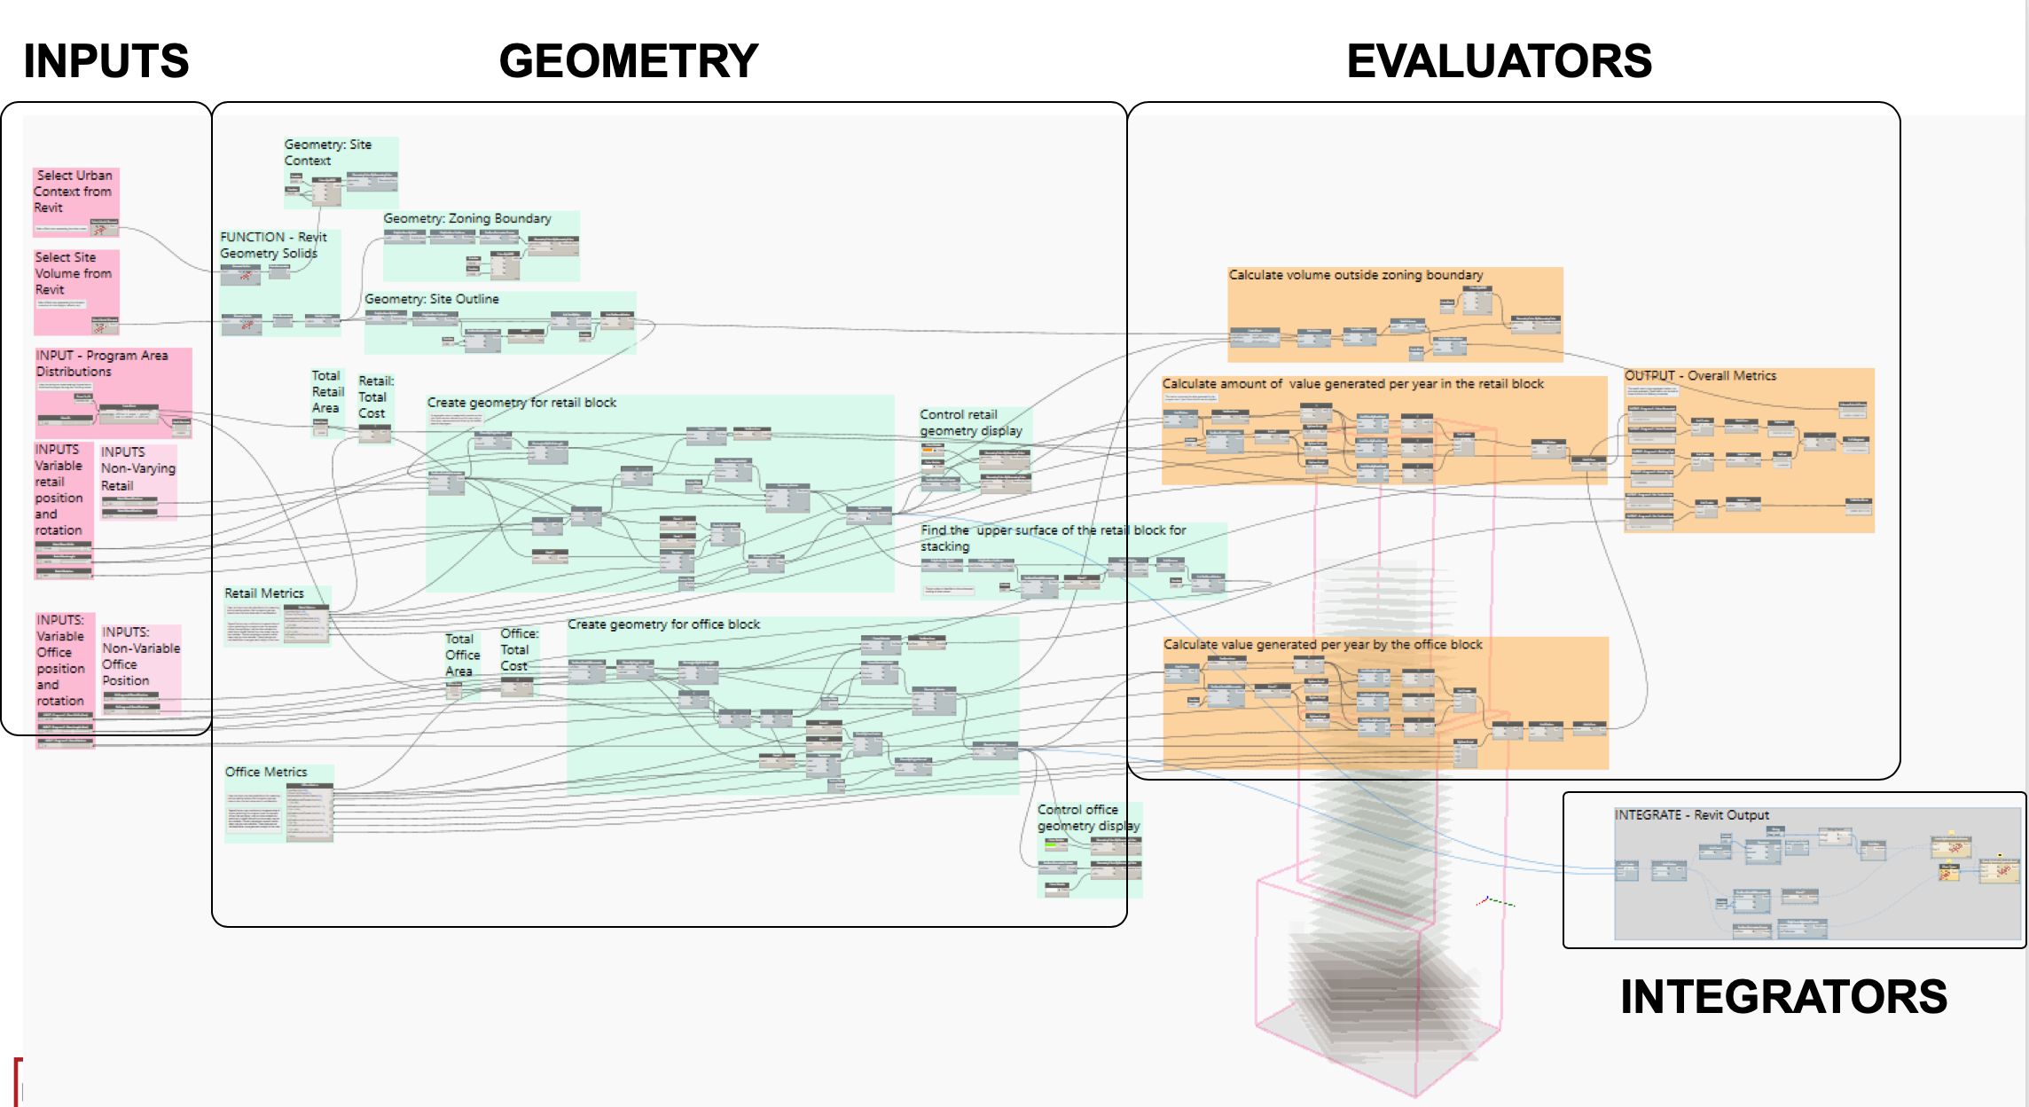

BuildingMasser-2programsBiLT_NA2019.dyn

First let’s look at the inputs. Users can set a gross square area and choose how to distribute the program among the 2 building parts of the building mass. Each building mass chunk can be controlled via length, width, and rotation with optional controls for position. These controls are set to not vary in Refinery, in order to focus the study on the size and rotation of the chunks.

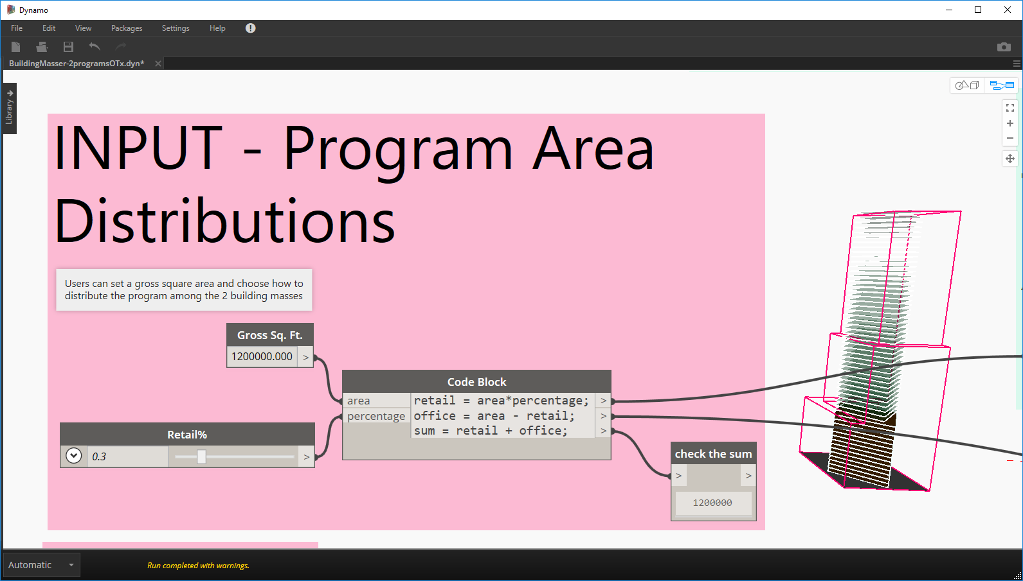

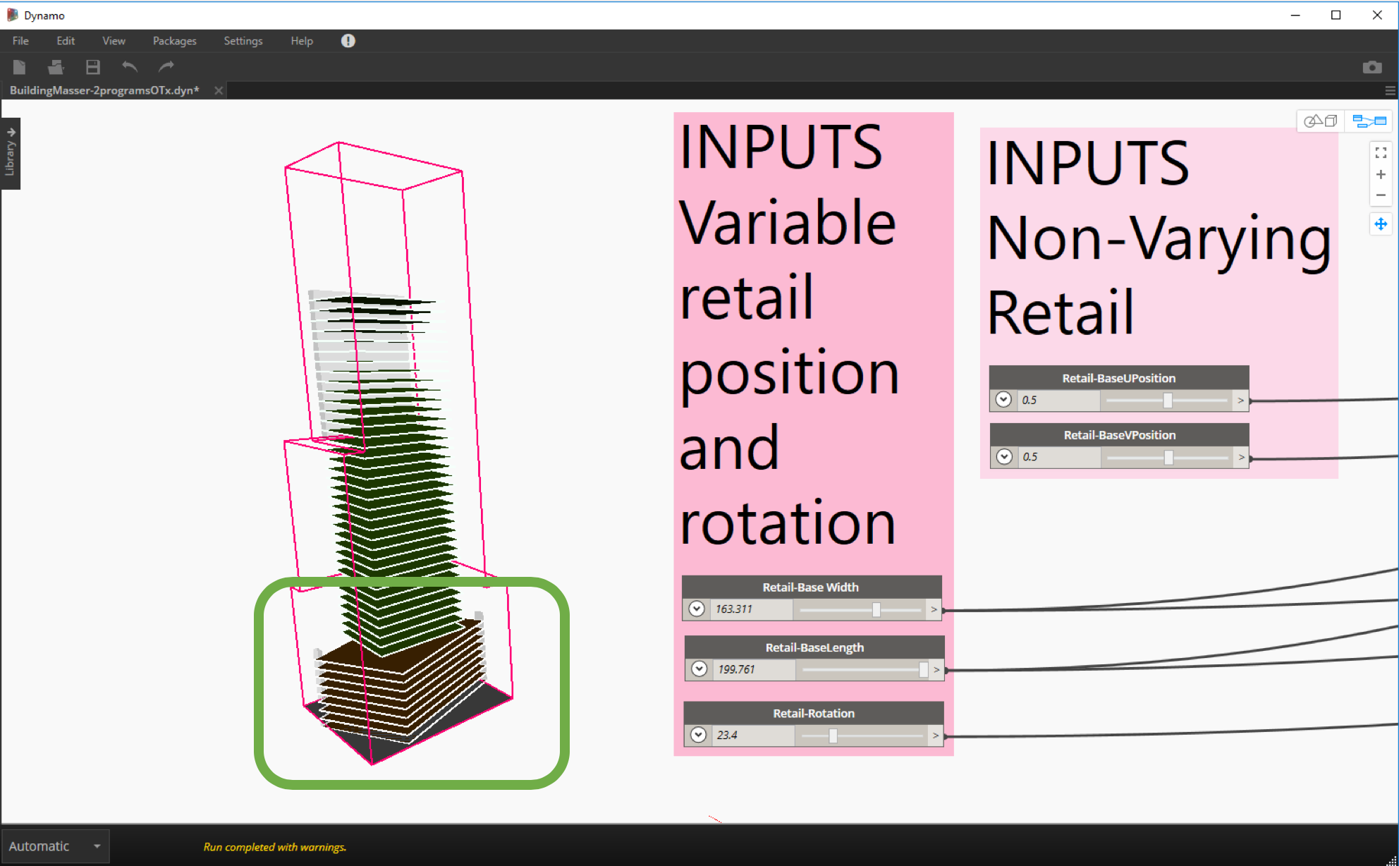

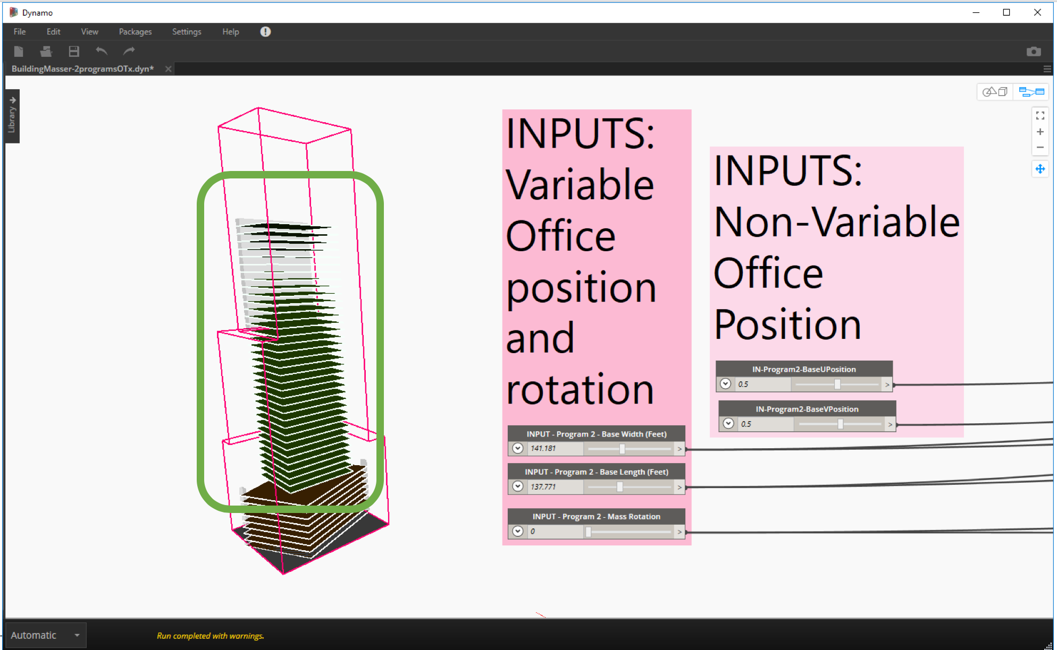

Next let’s look at the metrics that are used to guide the sizes and rotation of the building mass.

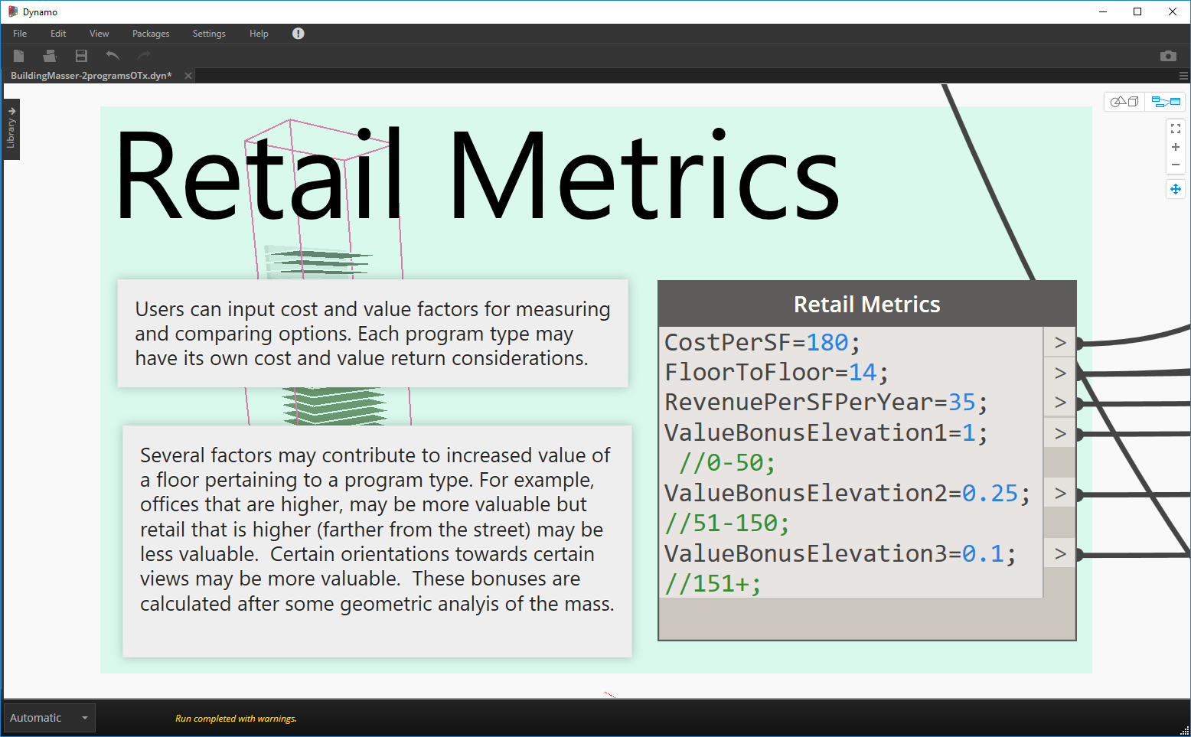

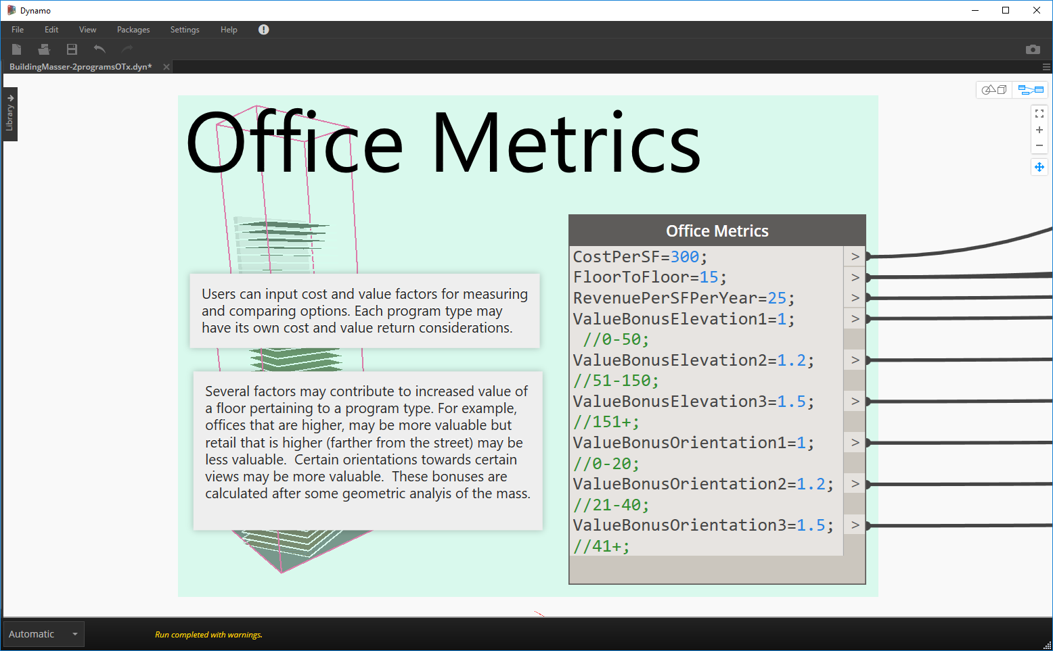

Summarizing and comparing the metrics:

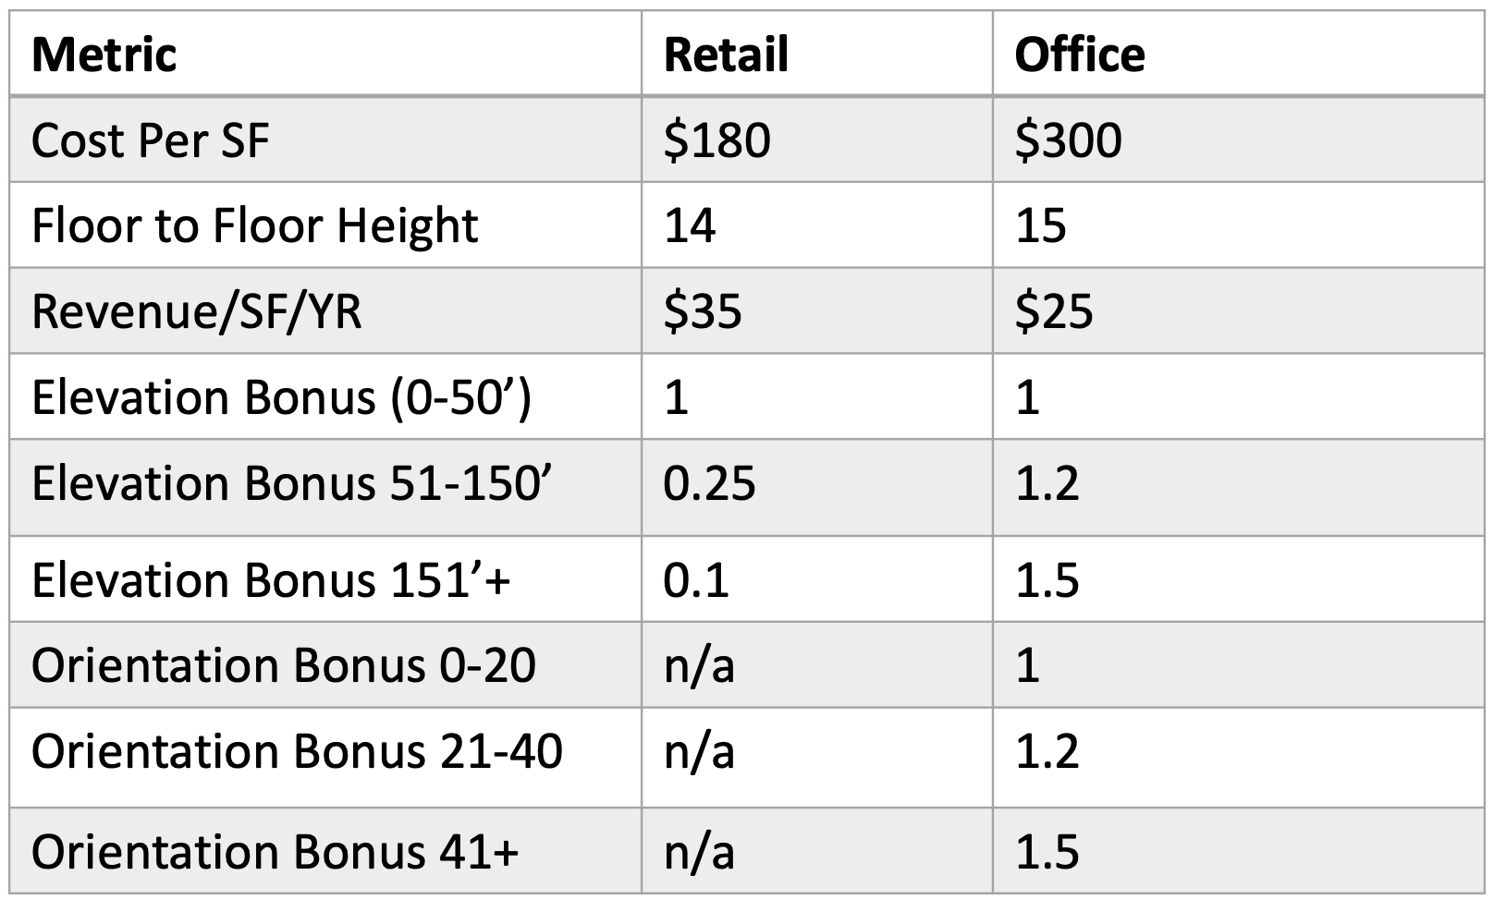

The next steps is to use the inputs to create geometry that can be flexed. Open the script to explore in more detail, but the primary functions of geometry creation in the graph are grouped as follows:

1. Create geometry for the retail block
2. Find the upper surface of the retail block for stacking
3. Create geometry for the office block (stacked on retail)

Once you have the geometry created and performance metrics designated, you can measure the outcomes via pretty basic mathematical calculations for:

1. Volume Outside Zoning
2. Total Value / Year
3. Years to Payback
4. Total Cost
5. Total Exterior Surface Area

Once the logic is described in Dynamo, you can then automate the generation of design alternatives that you can measure and rank against each other. Start by using the “Randomize” generation method to get an idea of the design space.

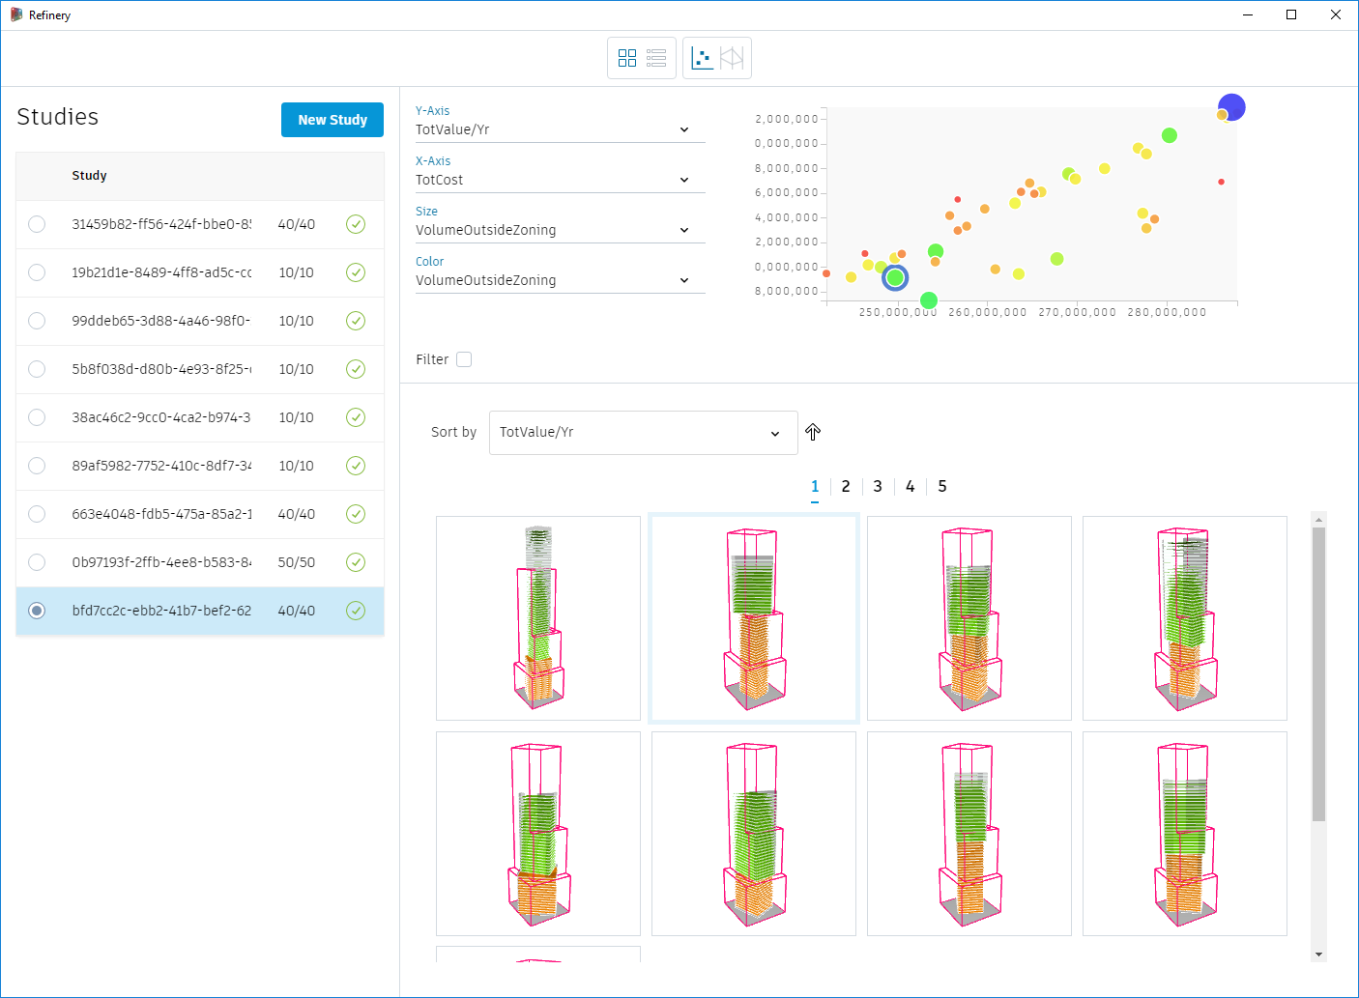

40 Randomized runs showing least TotalValue/Year

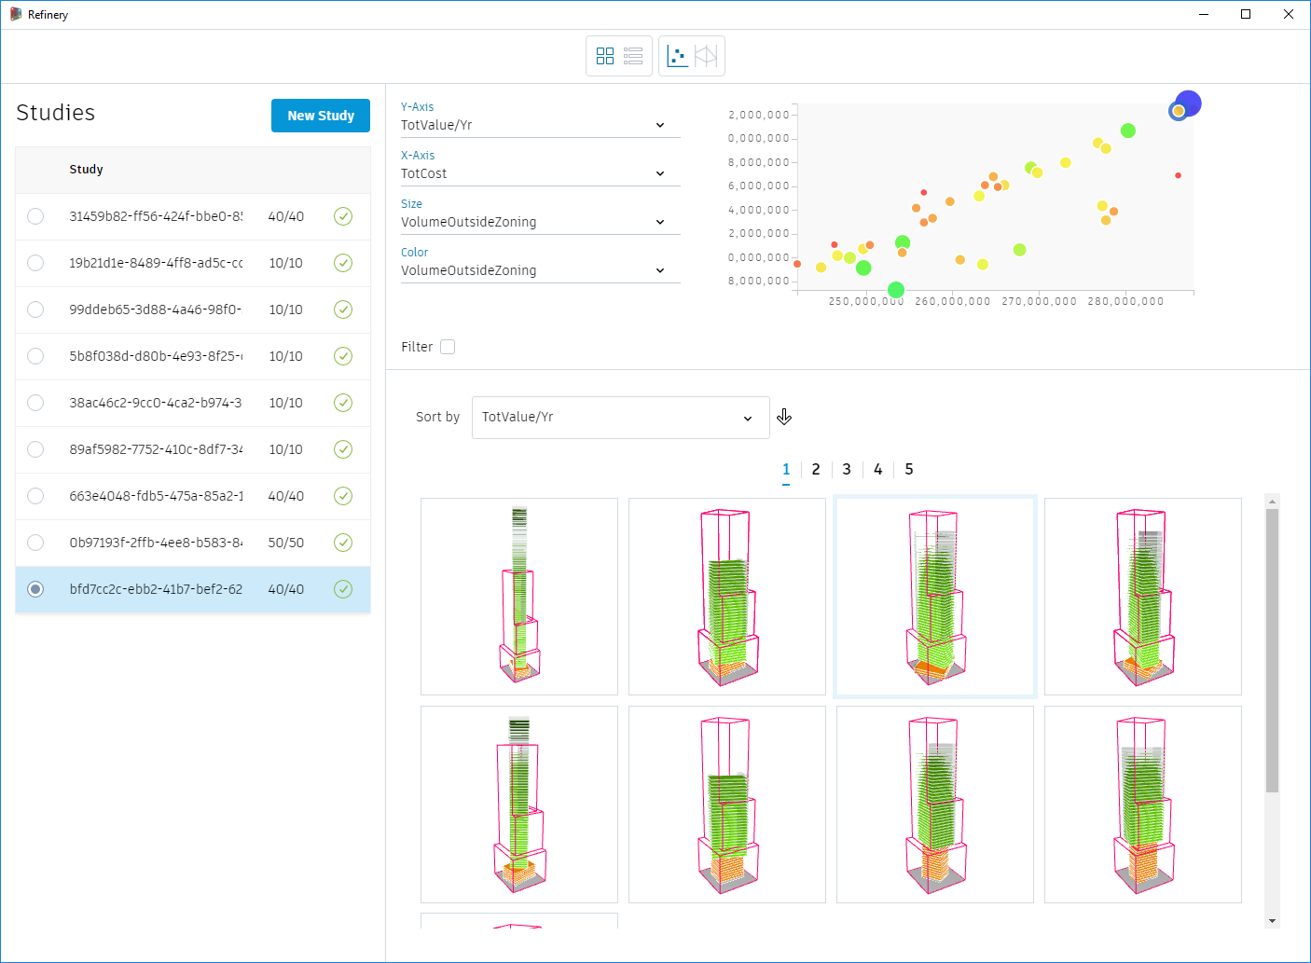

40 Randomized runs showing most TotalValue/Year

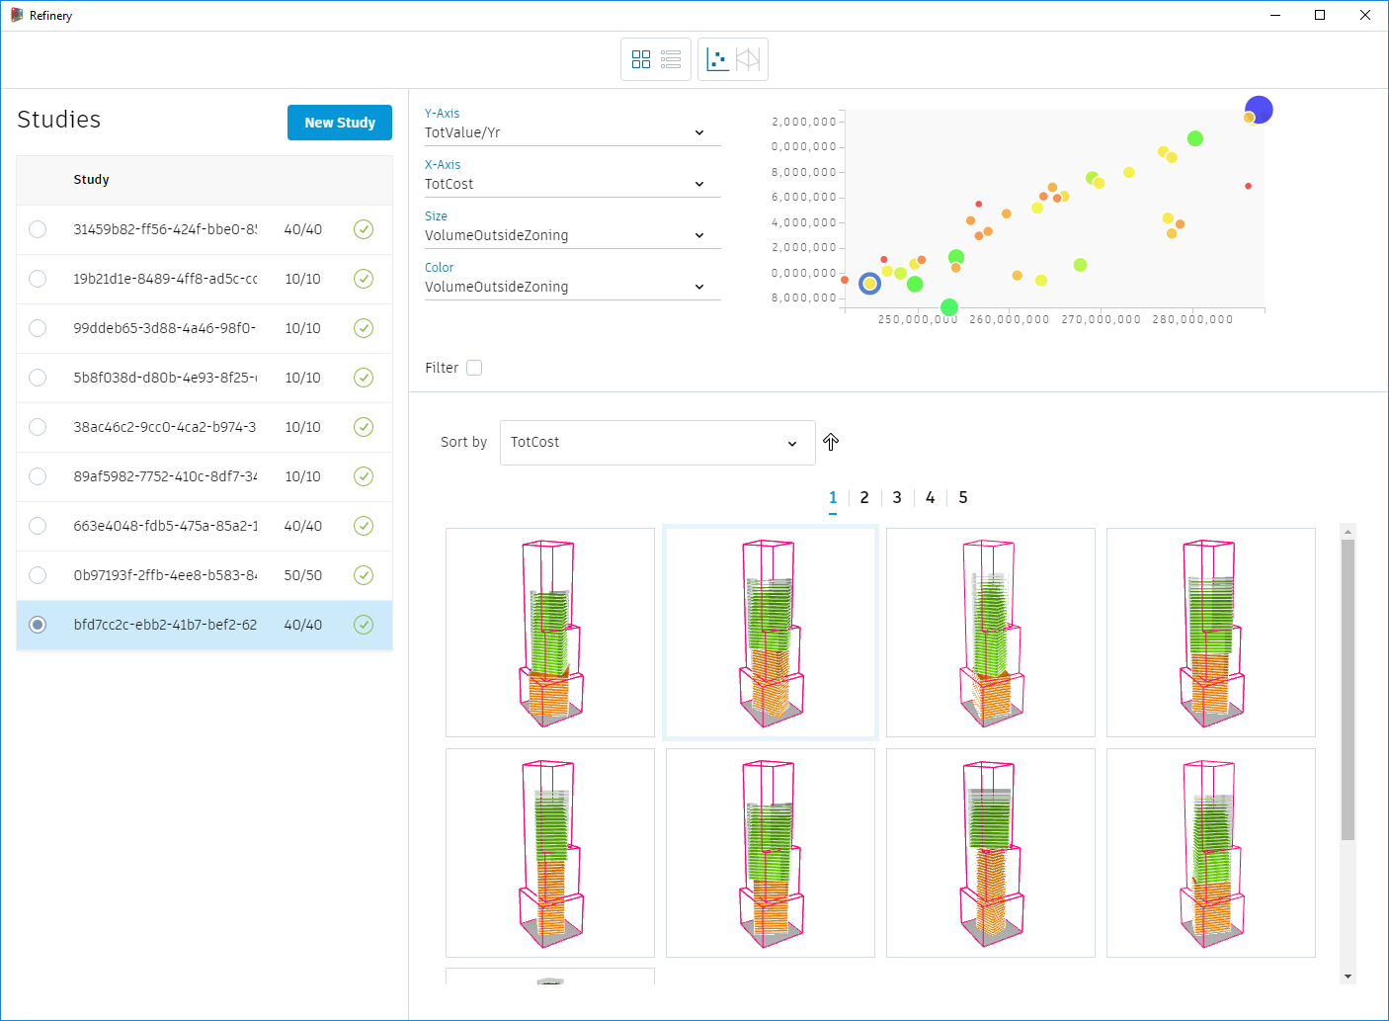

40 Randomized runs showing lowest cost

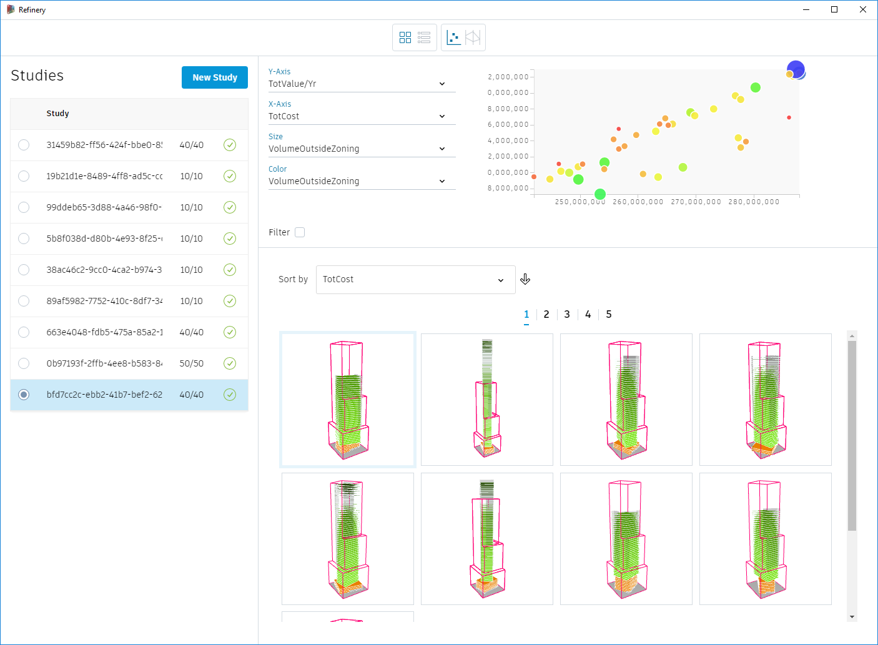

40 Randomized runs showing highest cost

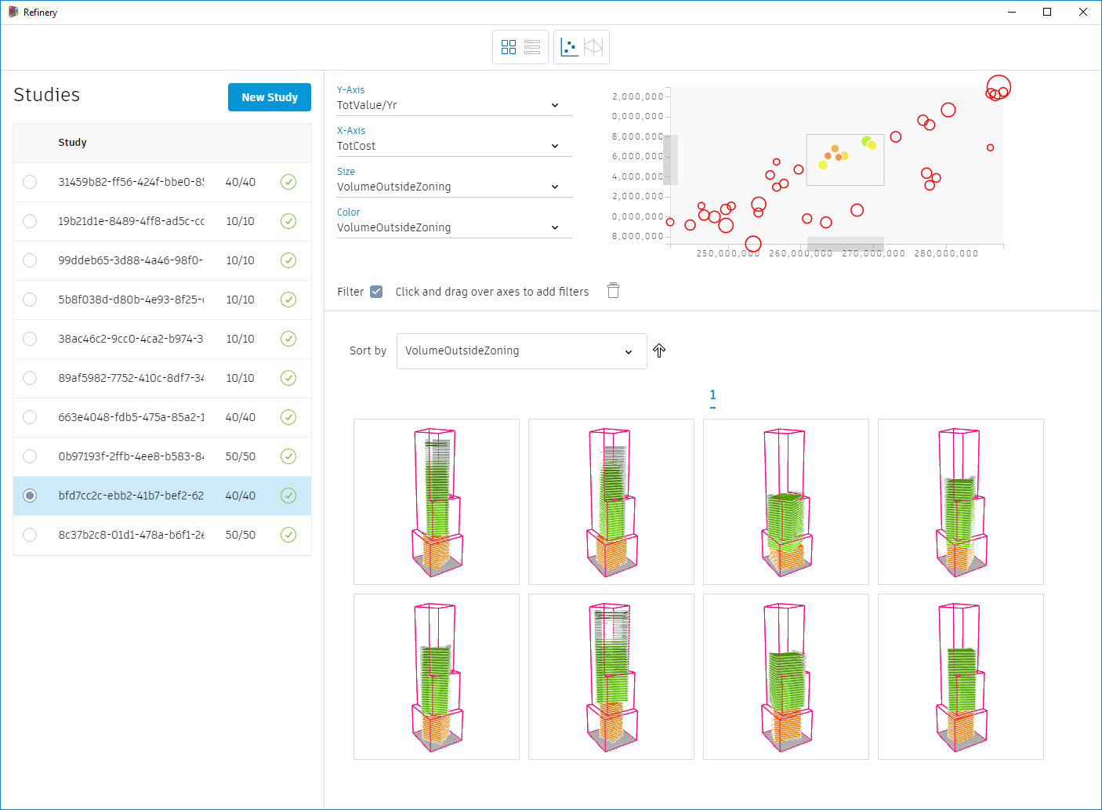

Use filtering to select options with median cost and value, sort by lowest Volume Outside Zoning

Finally, you can use the Optimize method to set goals before creating runs. If you set the Outputs to maximize Total Value/Yr, minimize Total Cost and minimize VolumeOutsideZoning, the computer will evolve the solution set towards designs that meet your stated goals.

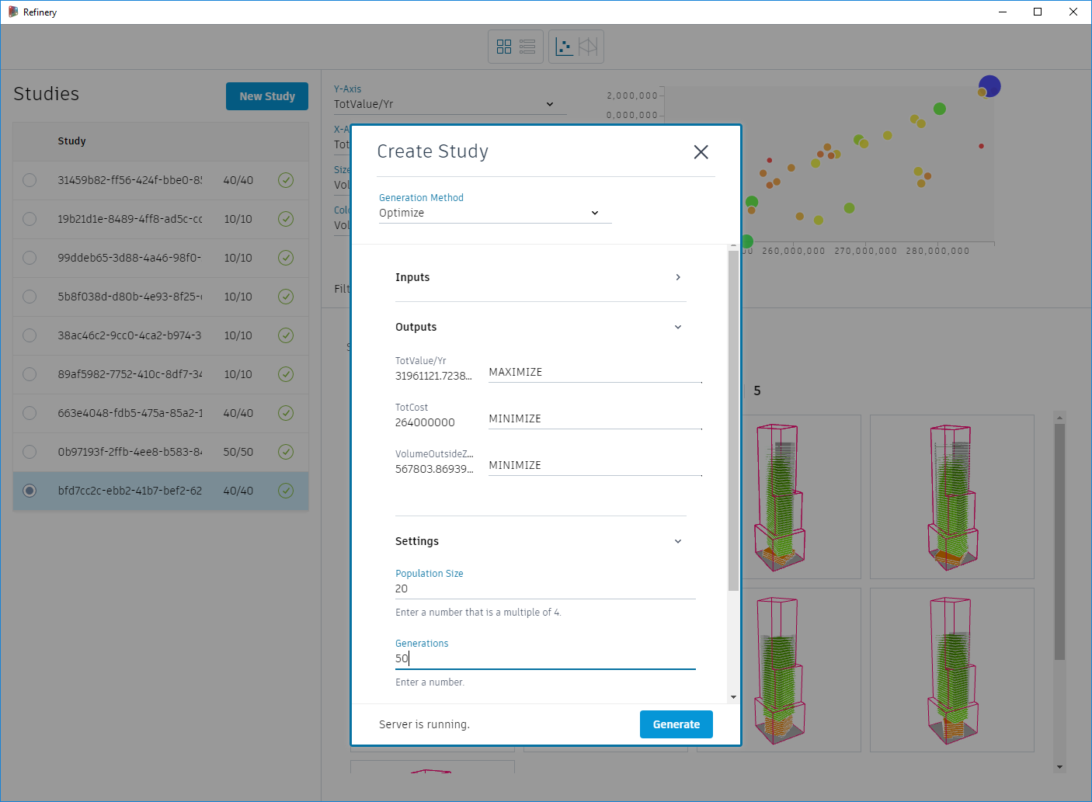

Setting up for an optimization run in Refinery

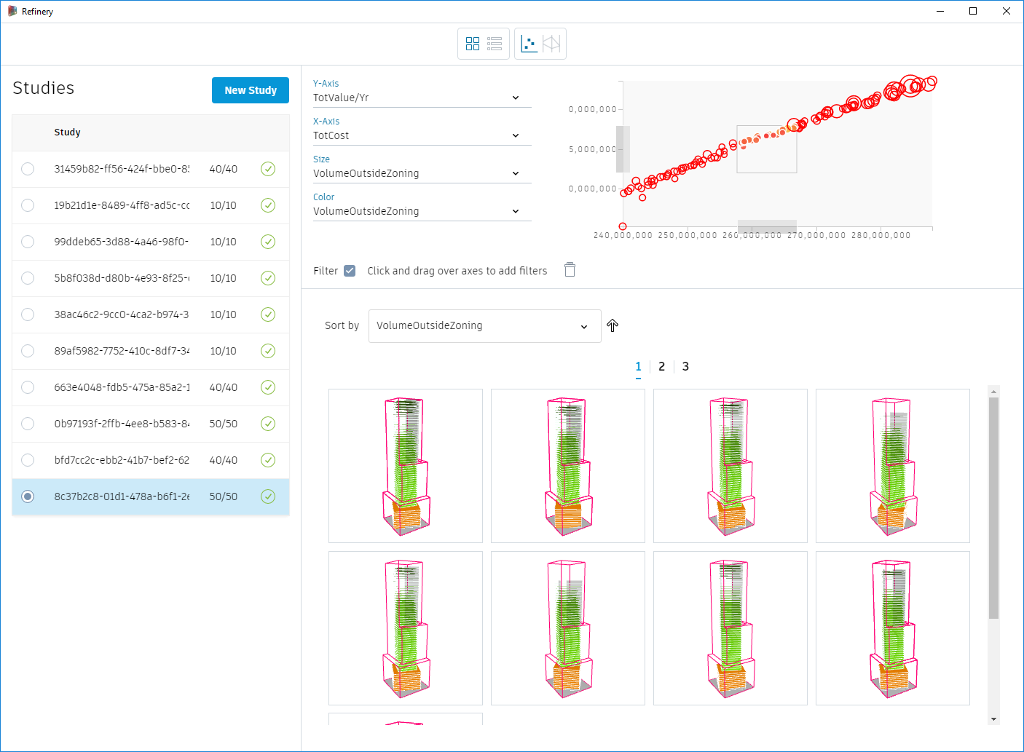

20x50 Optimization run filtered for medium Cost, medium Value, and sorted for lowest VolumeOutside Zoning

### Example 3.5: Stealthy RoofScapes

In this example we will show how to re-purpose an Evaluator from one Dynamo graph and re-use it in a new project.

Specifically there was a Dynamo Hackathon in London where a project was developed called Stealthy Roofscapes. The main project goal was to develop a system that tried to optimize for conflicting goals: Maximizing Building Volume but, at the same time, keeping the visible profile of the building at a minimum at street level. The project team developed a method of testing views from sample points on the street

### 

### Example 4: Solar Radiation

This study looks at how to lay out tiles on a surface coming from Revit.

* Variable Inputs:

1. Revit surface
2. Tile Width
3. Tile Length
4. Width Offset
5. Length Offset
6. Rotation

* Goals:

1. Maximize Full Tile Count
2. Minimize Partial Tile Count
3. Minimize Partial Tile Area
4. Minimize Discarded Area

Once again, the graph contains the same groupings as our previous example:

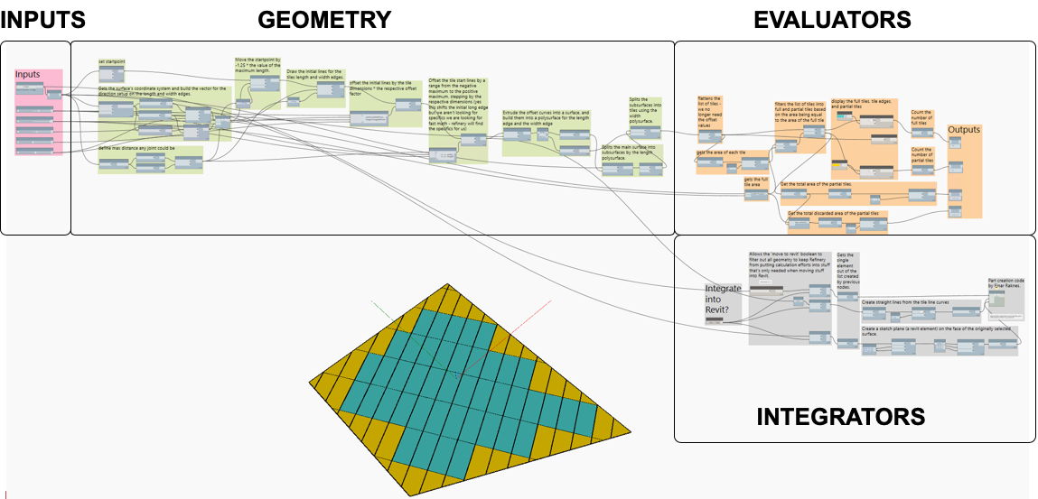

Let’s look at each section.

1. Inputs – the minimum and maximum range settings in Dynamo are critical to define the design space for variable inputs. Refinery will also take into account the Step value as set in Dynamo. Notice the settings for the Tile Width and Tile Length. Tile widths can only be 4,6,8,or 10. Tile lengths can only be 6, 6.5, 7, 7.5, 8, 8.5, 9, 9.5 etc…to a maximum of 12. Setting these ranges to reflect available tile sizes is necessary to guide the design system to produce useful design alternatives.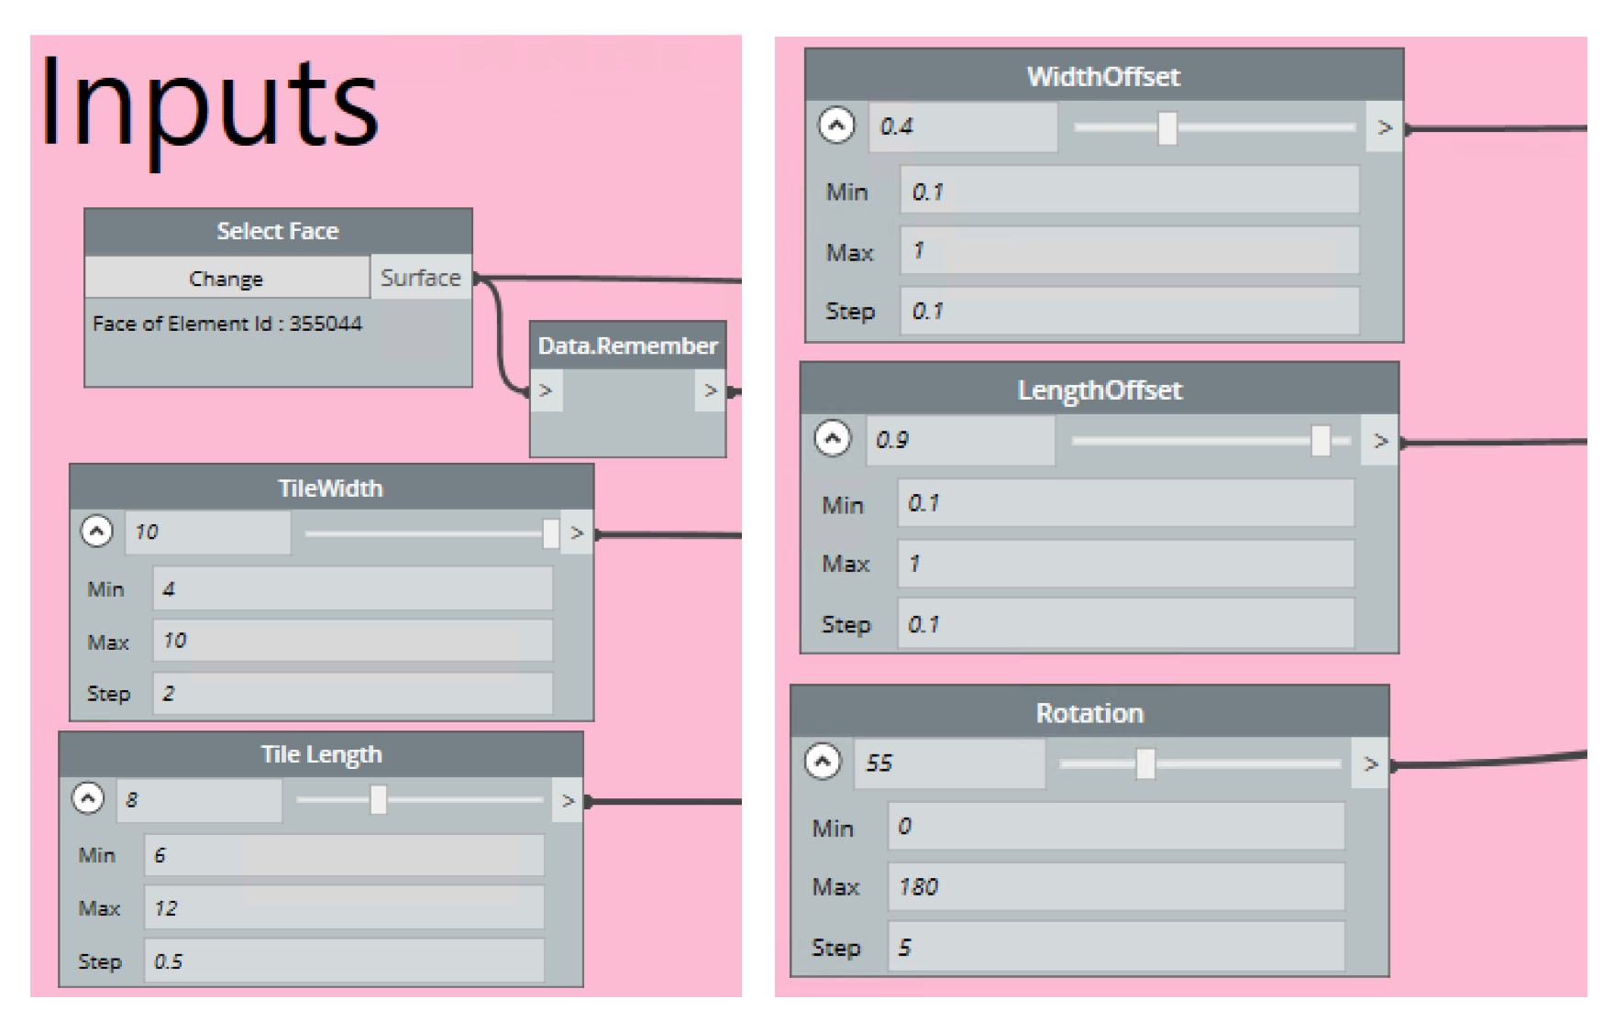
2. Geometry – The green section of the graph contains nodes which create the tile geometry. Open the graph to explore in more detail, but the basic idea is to understand the incoming surface for boundary conditions and maximum distances. Establish a variable starting point on the surface, draw the initial tile lines and then offset them. 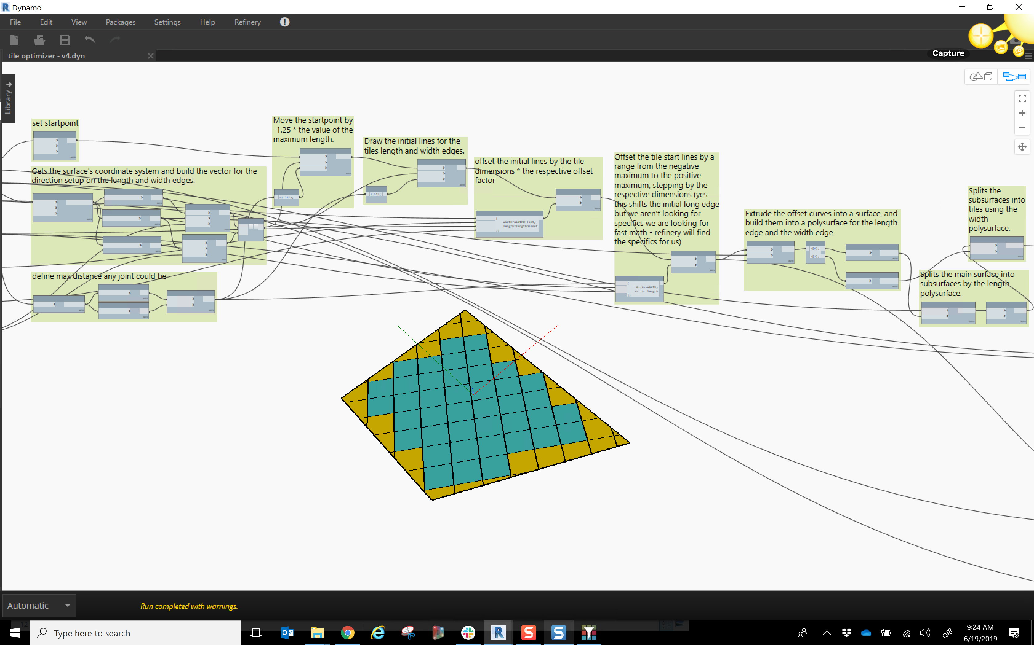
3. Evaluators – In the orange section of the script, the resultant tile layout is measured by :
   1. Counting the number of full tiles
   2. Counting the number of partial tiles
   3. Computing the total area of the partial tiles included in the layout
   4. Computing the total area of discarded partial tiles (amount of waste tiles)

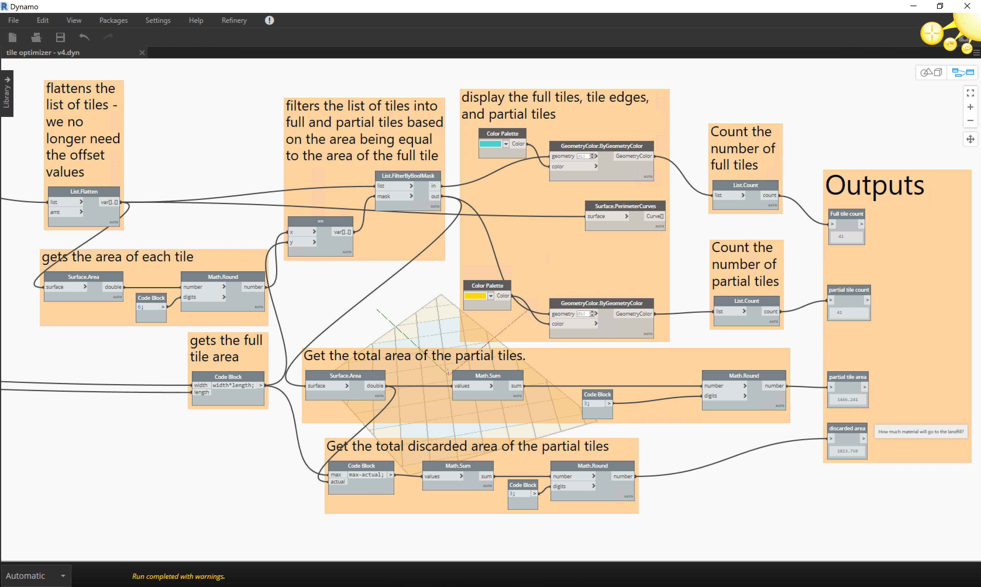

1. Integrators – the final grey section of the script contains nodes which can write a tile pattern back to Revit as parts. There is a Boolean node toggle at the start of this section which controls whether or not this section of the code is run. It can be turned off by toggling to “False” when running the script in Refinery and turned back on when you have selected a design and are ready to return the results to Revit. This section gets the Revit element that the original Revit surface was selected from and then uses the set tile pattern to create parts out of that element in Revit. The Part creation code happens in a Python node and was created by Einar Raknes. See <https://forum.dynamobim.com/t/dividing-parts-with-dynamo/5388/5?u=jacobsmall> for more details.

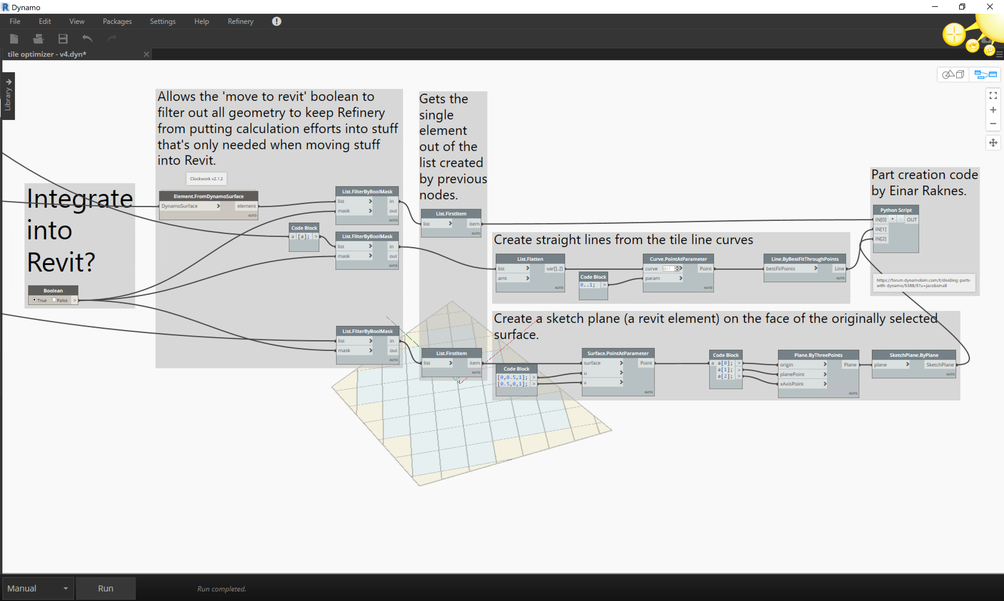

Now that we have our script ready we can look at how we can do automated design explorations using Refinery. First we’ll look at a run using the Randomize method to test the script.

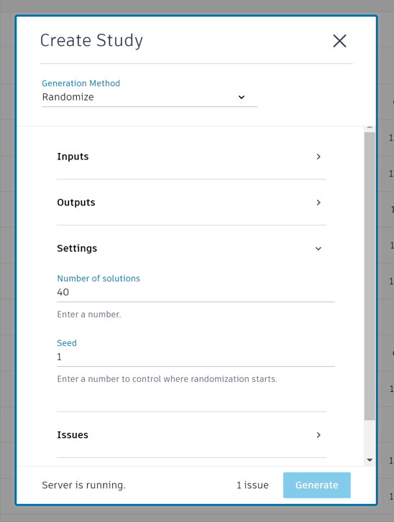

Generating 40 random options quickly gives us some results:

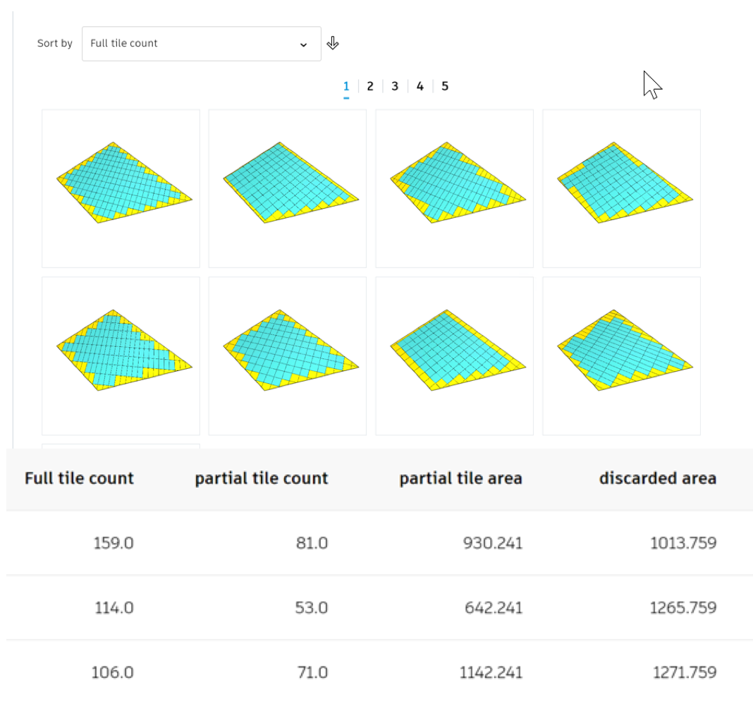

40 runs using Randomize method in Refinery

Now that we can see what the design system is capable of, we can make any adjustments we need to make to our input ranges or how the script is working. Or if the Random run yields decent results we can use the Optimize method to guide the results to meet our goals of maximum tile count, minimum partial tile count, partial tile area and discarded area. Performing an optimization run will give us design alternatives that are closer to our stated goals.

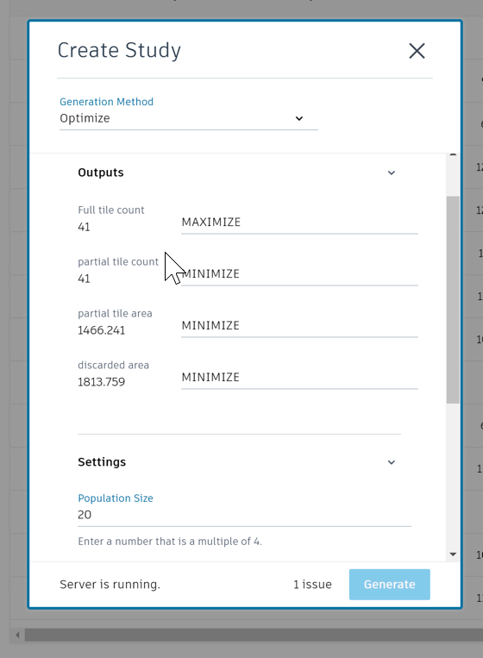

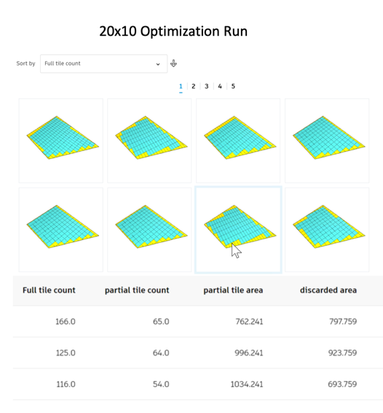

20x10 Optimization Run in Refinery

### Example 4: Open Office Layout

This script lays out desks given a Room element coming from Revit. In this study we will look at desk layouts that gives us the most desks but also the most private desks while maximizing desk area per person and maximizing space utilization.

* Variable Inputs:
  1. Edge to start layout
  2. Desk rotation
  3. Position on room surface
  4. Desk clearance
  5. End offset
* Goals:
  1. Maximize number of desks
  2. Maximize desk area per person
  3. Minimize unutilized space
  4. Maximize number of private desks

Once again, the graph contains the same sections as our previous examples:

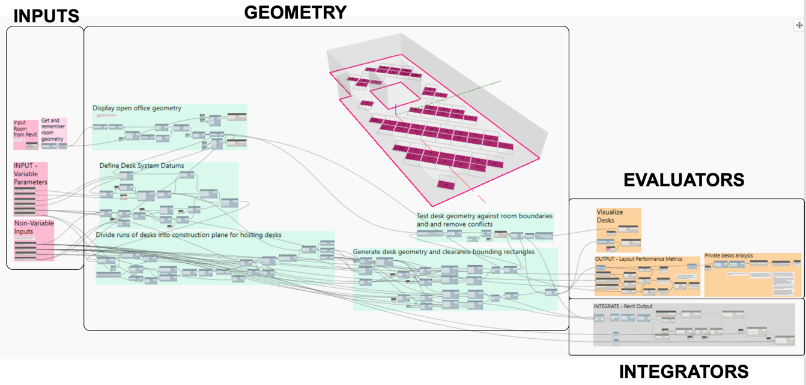

Let’s look at each section:

1. Inputs: The first input is a Room element coming from Revit. This gets remembered for use in Refinery.

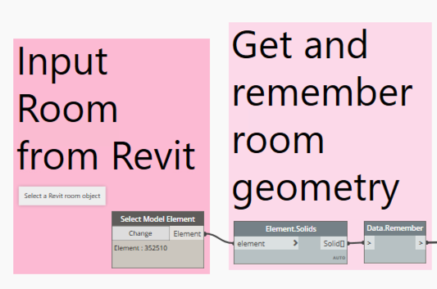

The next 2 groups of inputs are divided into variable and no variable inputs for clarity. The sliders in the first group are set to “Is Input” **on** via the context menu. These are the inputs that we want to vary in our study.

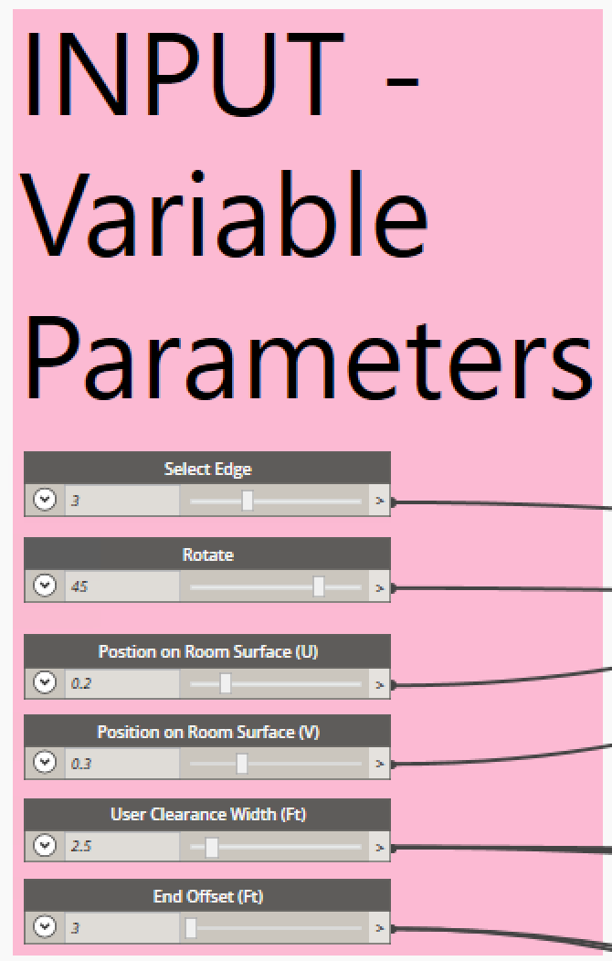

Variable Input Parameters

The sliders in the second group are set to “Is Input” **off** via the context menu. These are inputs that we want to remain constant during the study. Inputs can be changed to vary or stay constant by setting the “Is Input” flag in Dynamo or changing the variation option in Refinery.

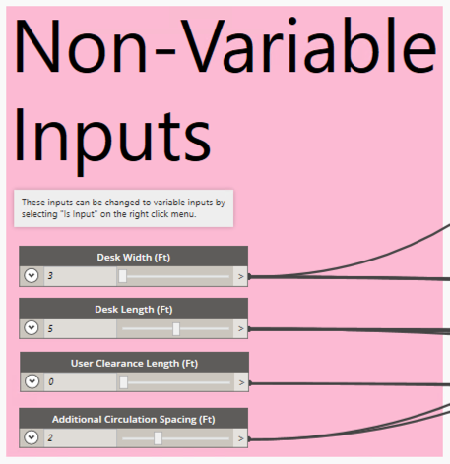

Non-variable Input Parameters

Be sure to consider how the maximum, minimum and step values are set for the range of your sliders so that you can limit the results to desirable values. For example, here, the rotation step value is set to 15 with a range of -90 to 90 so that the system won’t return many options with tiny rotation changes.

1. Geometry – The green section of the graph contains nodes which create the desk layouts based on the room geometry coming from Revit. Open the graph to explore in more detail, but the basic idea is to process and display the room geometry coming from Revit. Then define a system of datums based off of this geometry. Next, runs of desks can be divided into construction planes for hosting each desk. Then the desk geometry and clearance rectangles can be drawn. Finally, the geometry is compared against the room boundaries and any conflicts are removed.

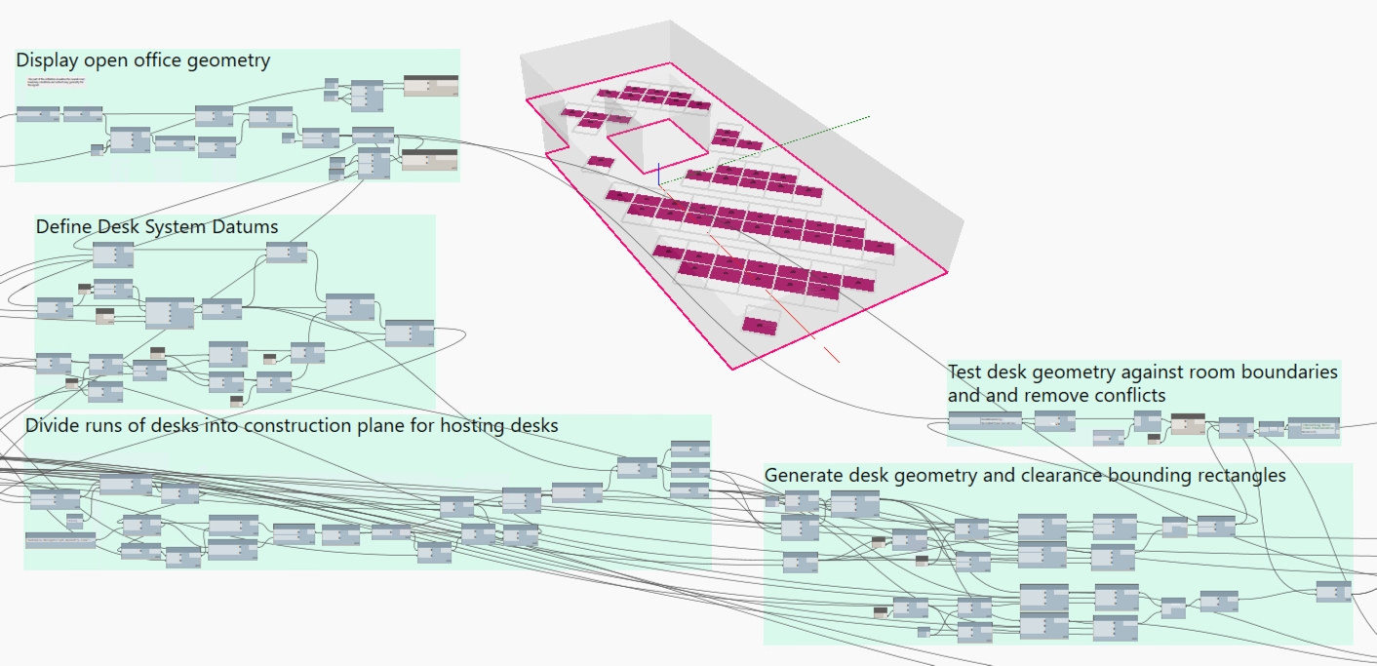

Geometry section of OpenOfficeLayout.dyn

1. Evaluators. In the orange section of the scripts, the designs are evaluated against our established goals. The first orange section counts the number of desks, calculates the Total Area per Person and the Area Utilization. These nicknamed watch nodes are all set as “Is Output” so that Refinery will recognize them as outputs.

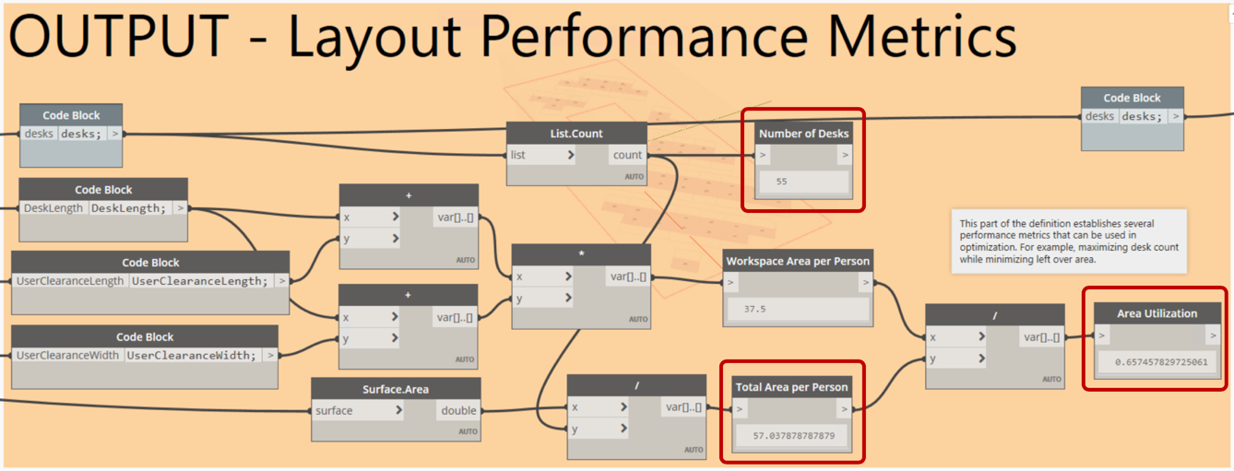

Desk Layout metrics

In the second orange section, we perform some calculations to count the number of “private desks”. This calculation does the following:

1. Measure how far each desk is from the other.
2. Count the number of desks that are less than 12' from each other
3. Count the number of desks that have less than 3 desks that are less than 12' away.

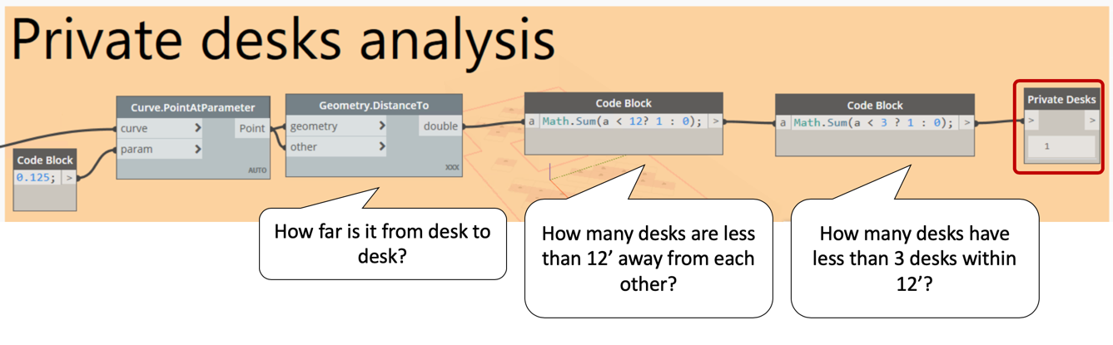

Note that both the “12’ distance” and “3 desks within 12’ “ evaluator rules are somewhat arbitrary. I noticed I could hear my neighbours if they were at a desk less than 12' away, but I was oblivious to whoever was at a desk more than 12' away. But….privacy at work is relative. Is there white noise in your office? What kind of work are you doing? Are you workers doing loud things or talking at their desks? Someone who only cares about what shows on screen might be fine sitting within 12’ of 3 or more people, but someone who needs audio privacy might not be ok with being within 12’ of even 1 person. For this study, we have defined “Private Desks” as described above. Let’s see how we can use it to guide design decisions.

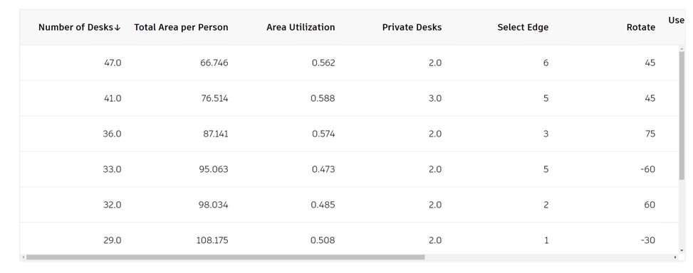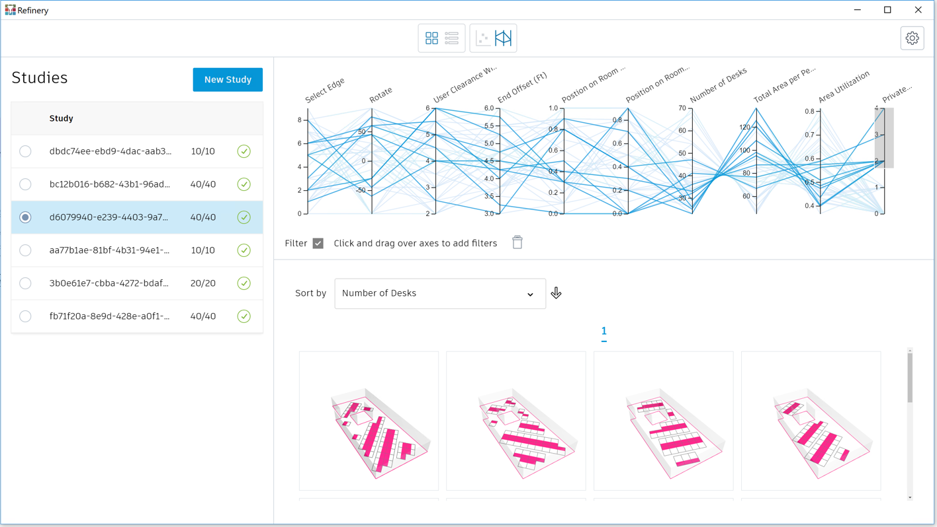The first step is to do a run using the “Randomize” method. After generating 40 designs, we can use the Parallel Coordinates chart view to filter for alternatives that have the most number of “private desks” and then rank that result by alternatives that have the most desks. Design alternatives that rotate the desks seem to give us some interesting options along the lines of what we’re looking for.

40 Random runs, filtered by most Private Desks and sorted by most Desks

Let’s see if an optimization run will get us even closer to our goals. Using Refinery, create a new Study using the Optimize generation method and the following output settings. The most private desks we get are 3 with 41 total desks.

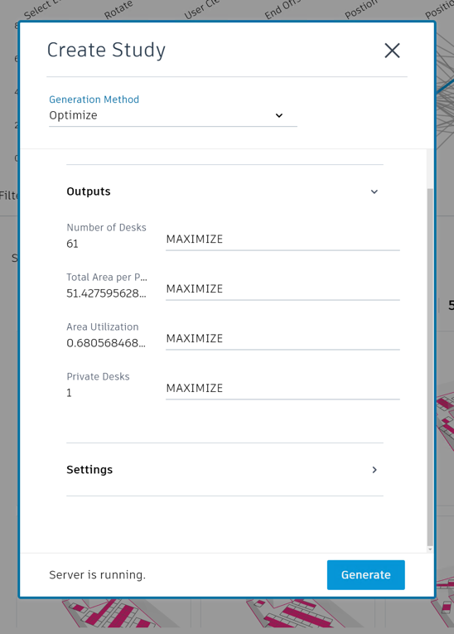

Optimization settings in Refinery

The optimization run does give us some even better results. Now we see options with 4, 5, and 6 private desks and total desk counts of 41, 46, and 41 respectively. We can continue to sort, filter and rank the results to evaluate the different designs quickly. If the underlying room geometry changes, we can simply run the study again.

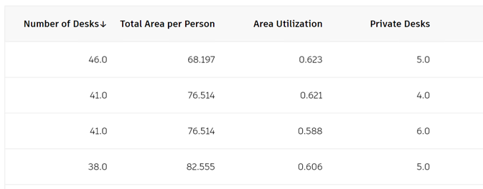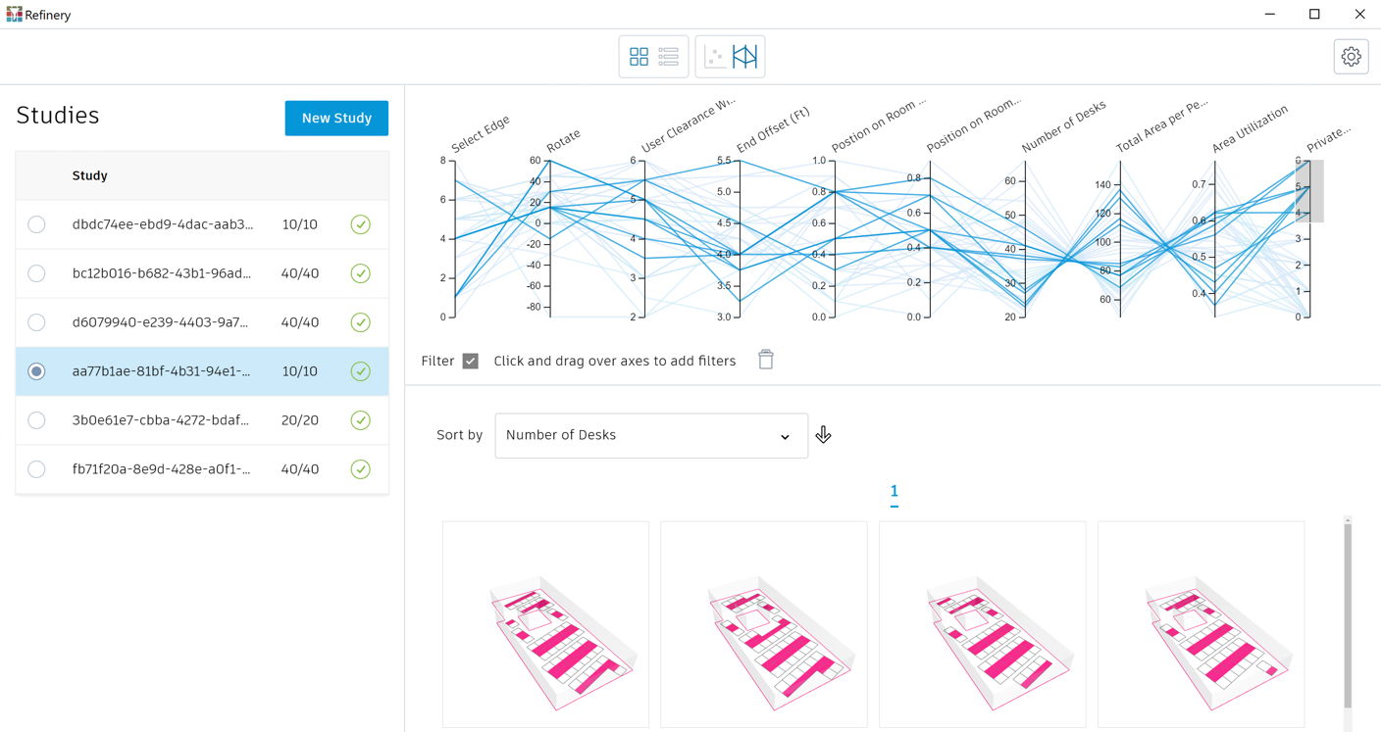10x20 Optimization run filtered by most Private Desks and sorted by most desks

1. Integrators. The final step is to take the chosen design and return it to Revit for further development. The Integrate group takes desk location and rotation and place Revit families. It also sets Revit parameters for desk width and length.

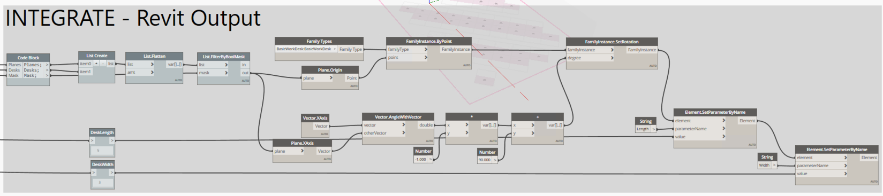

### Conclusion

We hope that these examples will give you some ideas about how you can start to use generative design workflows with Dynamo and Revit. Keep in mind that there are many different scales of workflows where you can use generative techniques from very complex examples like the Mars Toronto Autodesk offices (see <https://www.keanw.com/2019/06/project-rediscover-is-now-available-for-download.html> for more details and the Dynamo graph) to very simple examples like 3Box which can be extended and adapted for specific workflows – see <https://www.youtube.com/watch?v=uqFgg2Dorec> for example. We encourage you to share your work with #ProjectRefinery, ask question on the Dynamo and Refinery forums or contact us at [refineryfeedback@autodesk.com](mailto:refineryfeedback@autodesk.com).

# Additional Resources

1. Getting Started with Dynamo: <https://primer.dynamobim.org/>
2. Dynamo Questions, inspiration: <https://forum.dynamobim.com/>
3. Design Script: <https://dynamobim.org/wp-content/uploads/forum-assets/colin-mccroneautodesk-com/07/10/Dynamo_language_guide_version_1.pdf>

Or <http://designscript.io/DesignScript_user_manual_0.1.pdf>

Or <https://dynamobim.org/wp-content/links/DesignScriptDocumentation.pdf>

Or <https://github.com/Amoursol/dynamoDesignScript>

1. Refinery: <https://www.autodesk.com/solutions/refinery-beta>
2. Refinery Primer:
   1. <https://refineryprimer.dynamobim.org/>
   2. <https://github.com/DynamoDS/RefineryPrimer>
3. Refinery Toolkit Dynamo Package and Examples Files:
   1. <https://github.com/DynamoDS/RefineryToolkits>
4. Generative Design education: <https://medium.com/generative-design>